**PatientPartner - Gabi**

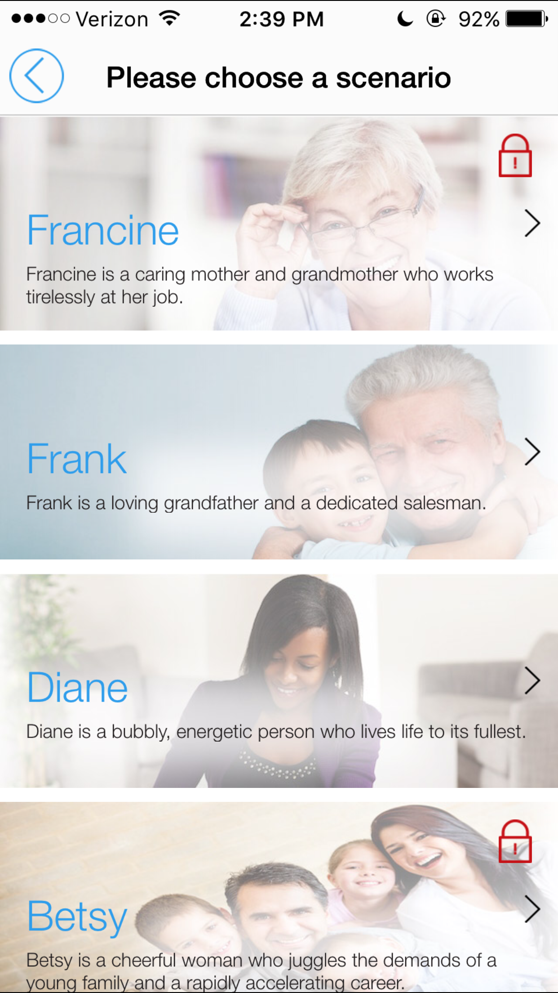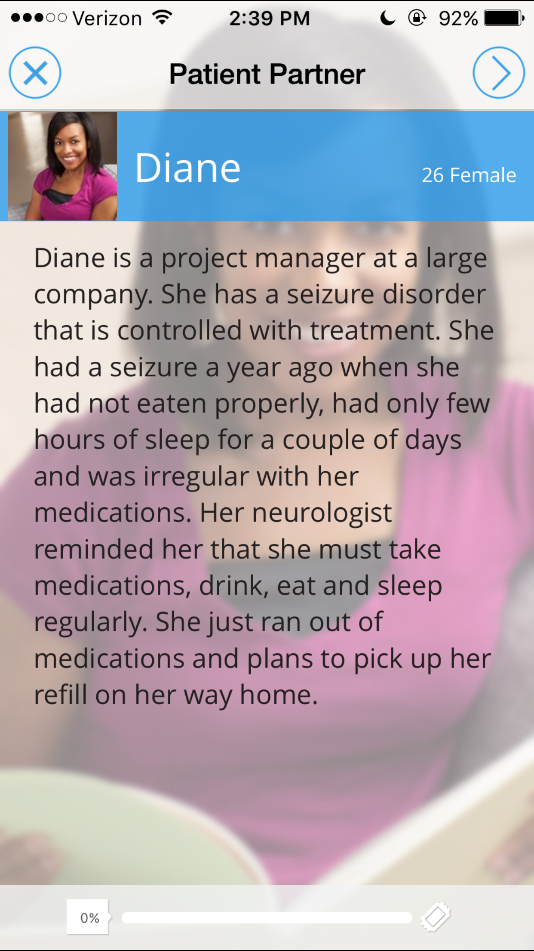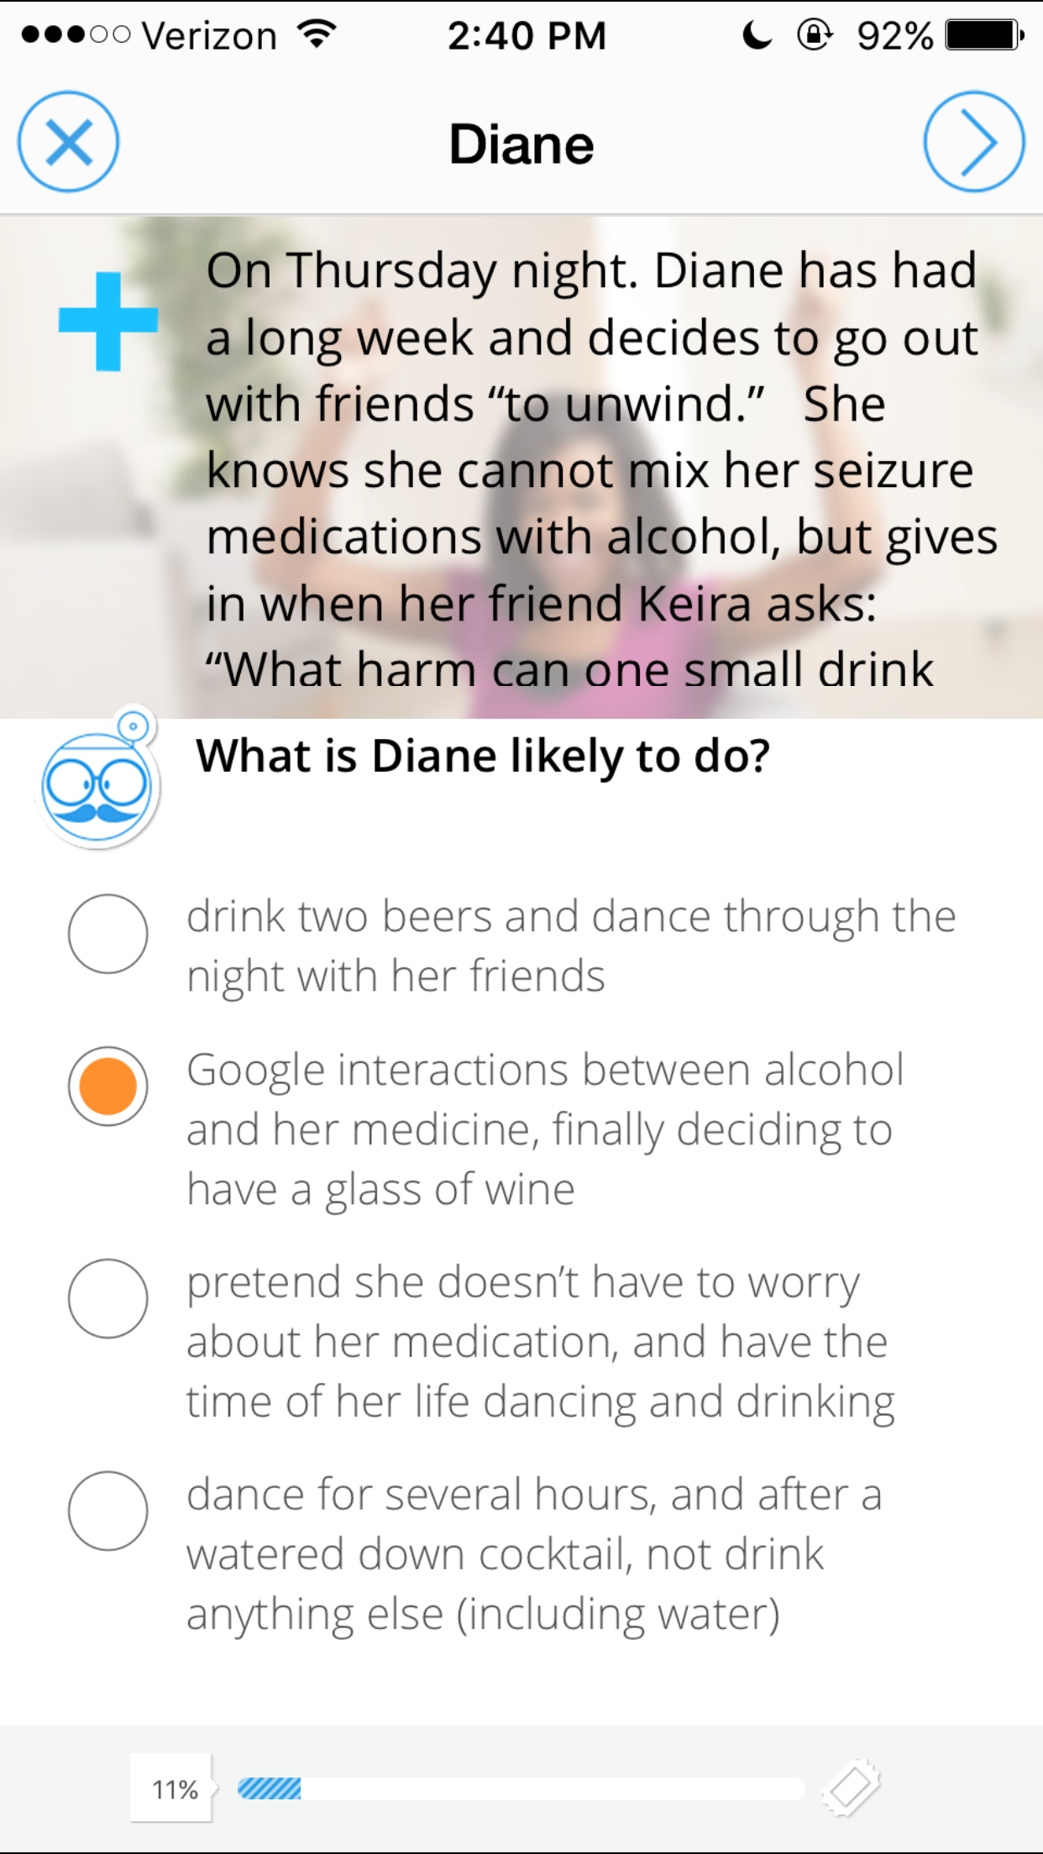

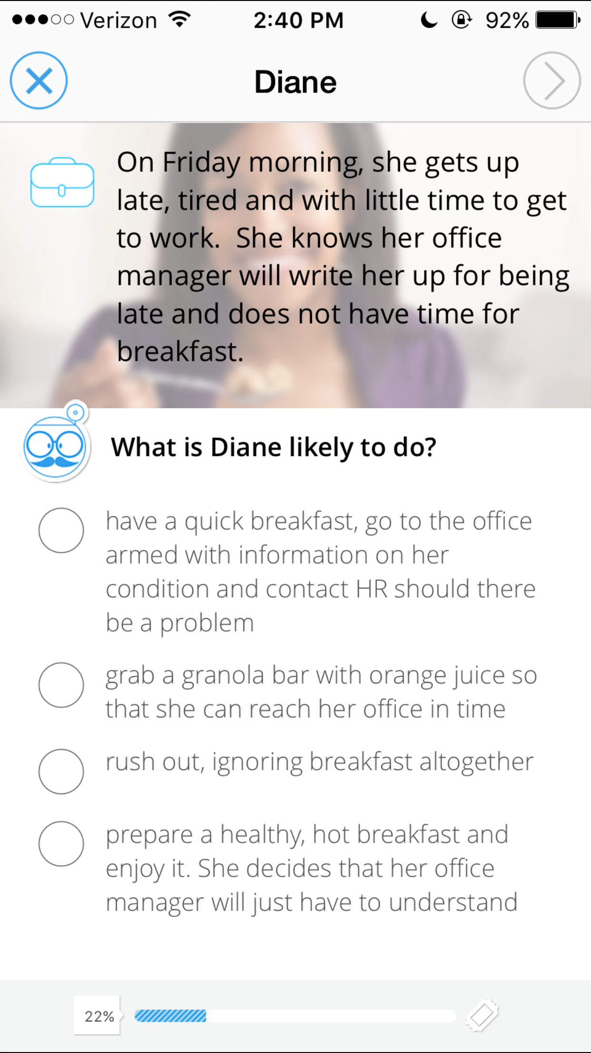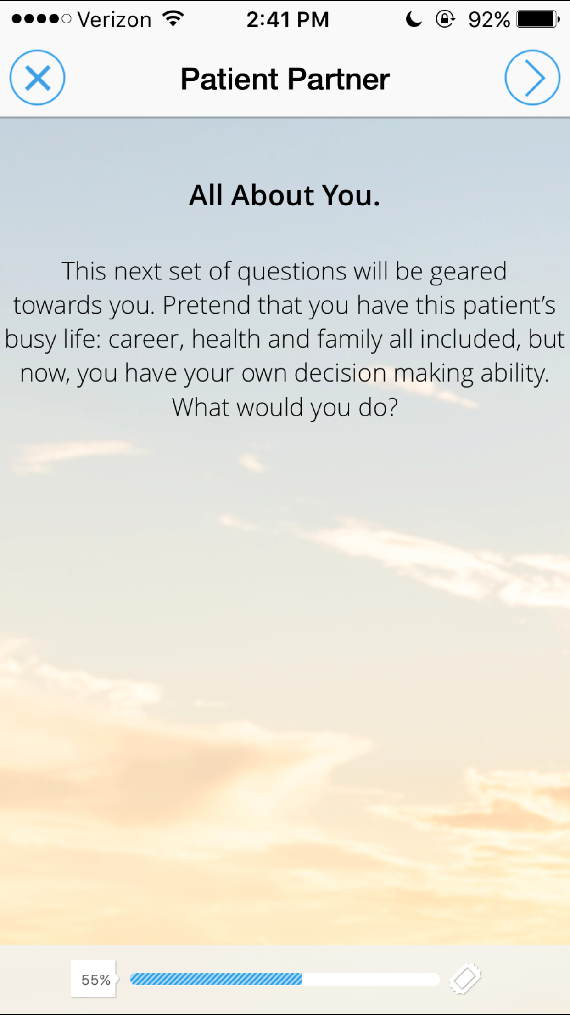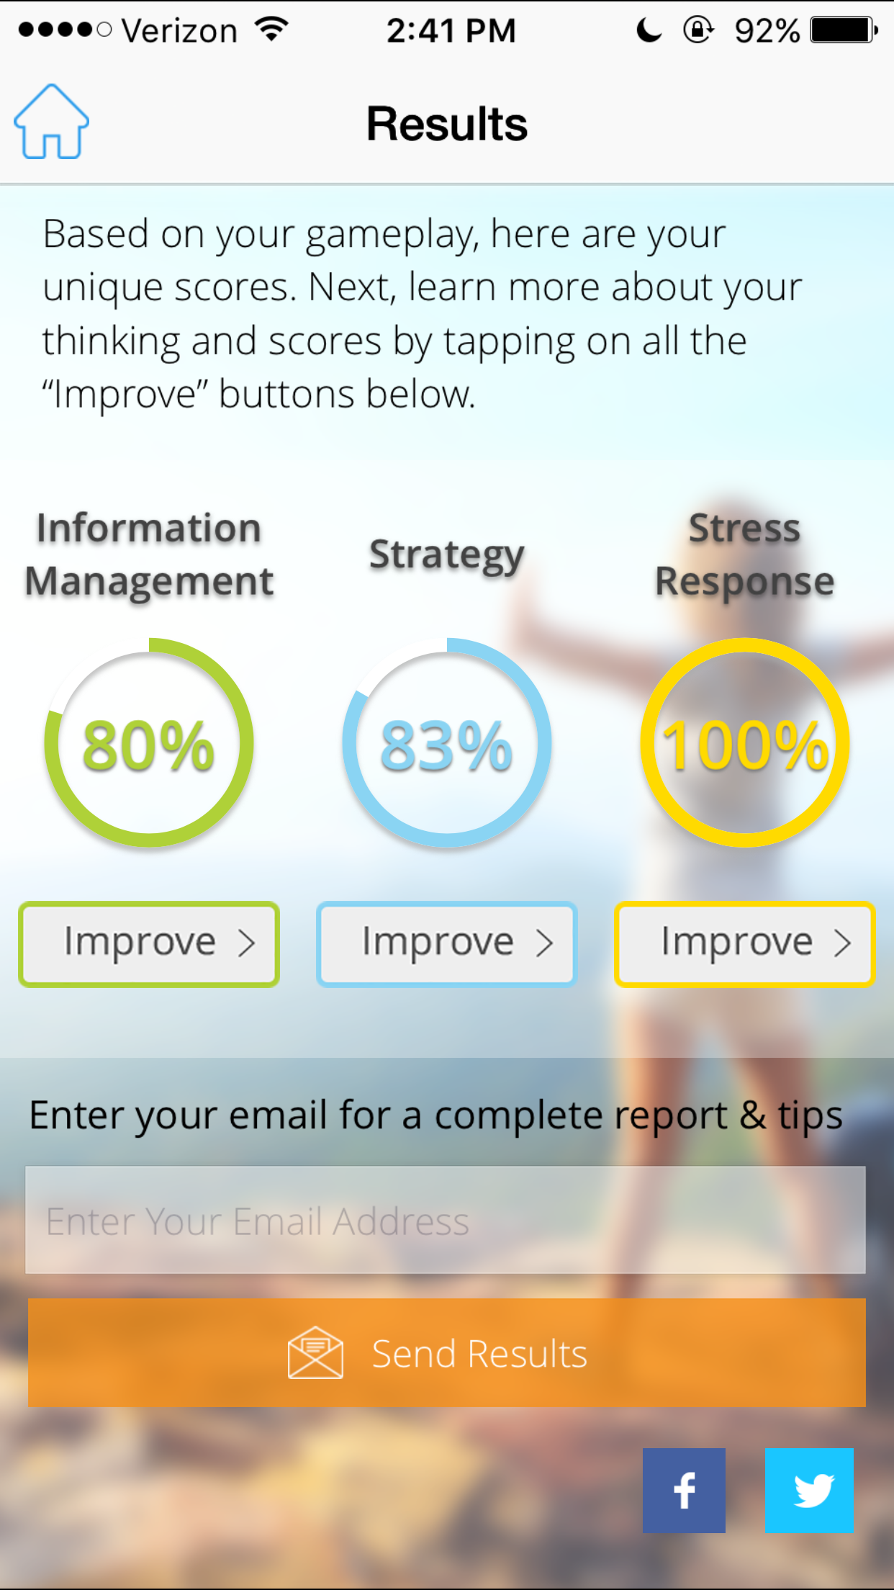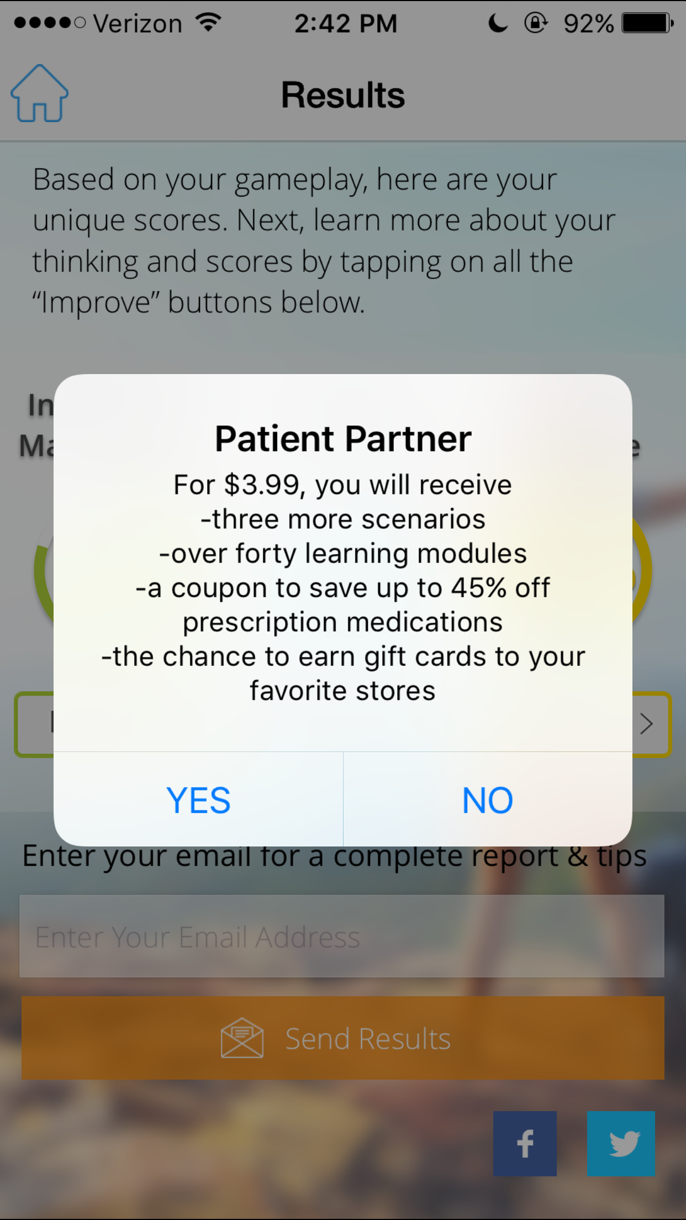

* This app walks patients through potential scenarios to determine their ability to manage information, strategize, deal with stress and more.
* It then (for a fee) teaches strategies to improve these skills
* Good idea for teaching skills, but scenarios unrealistic, non customizable, and unhelpful
* Not sure why it was on a list of best apps to help manage medications…

**Medisafe - Gabi**

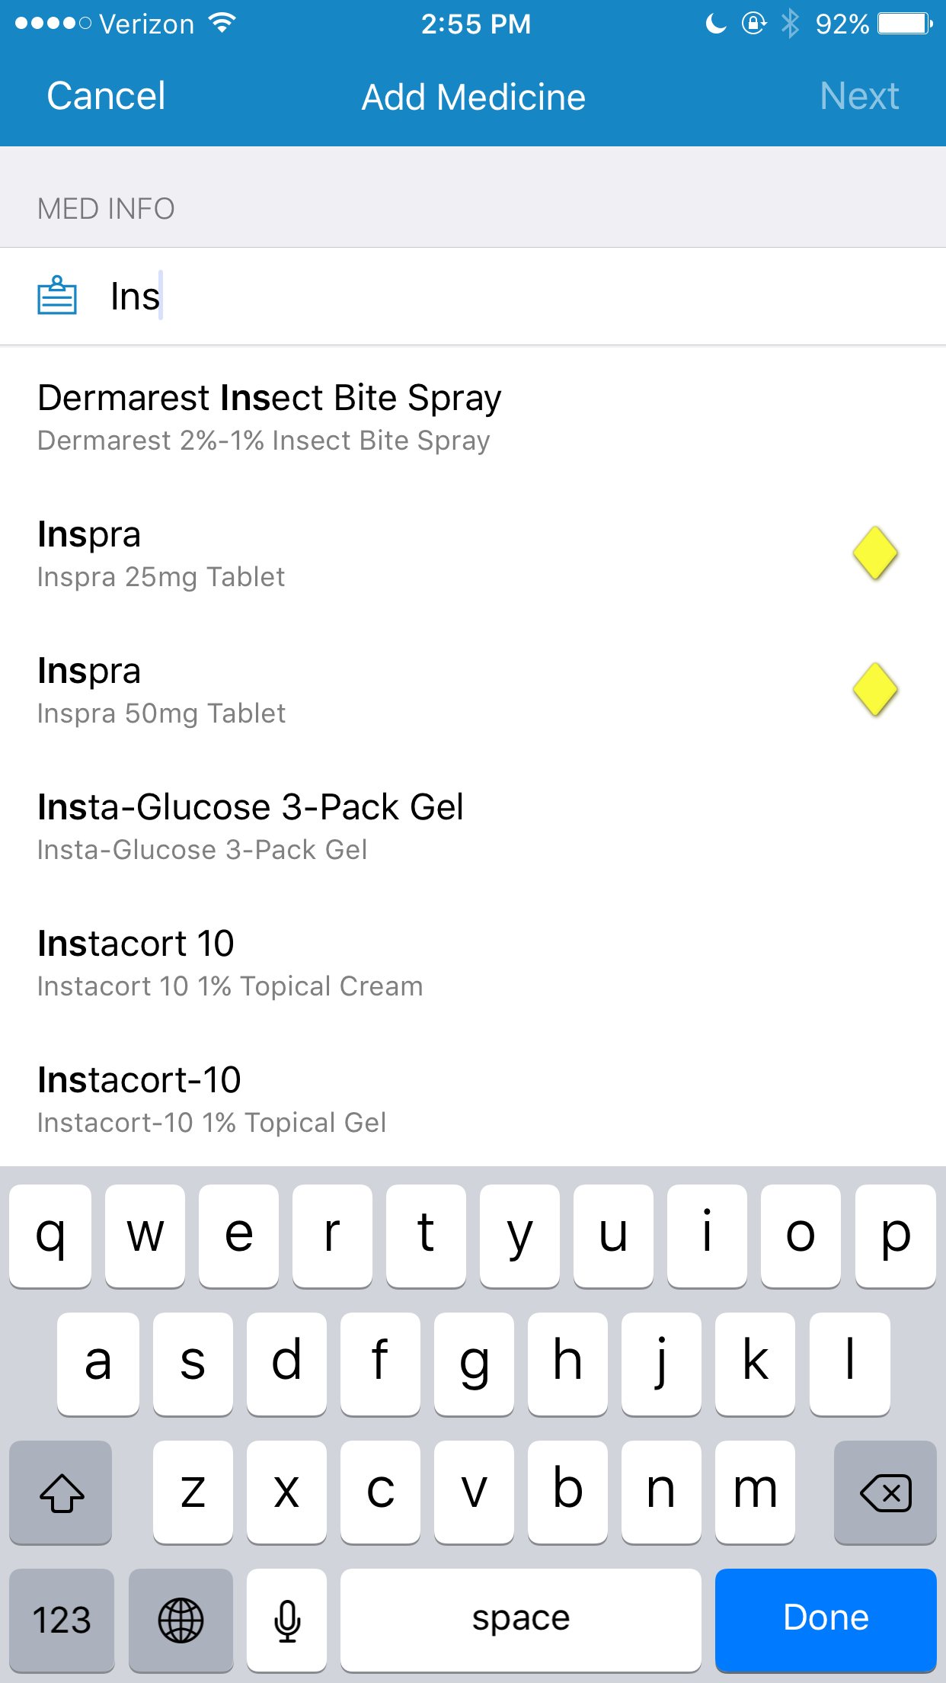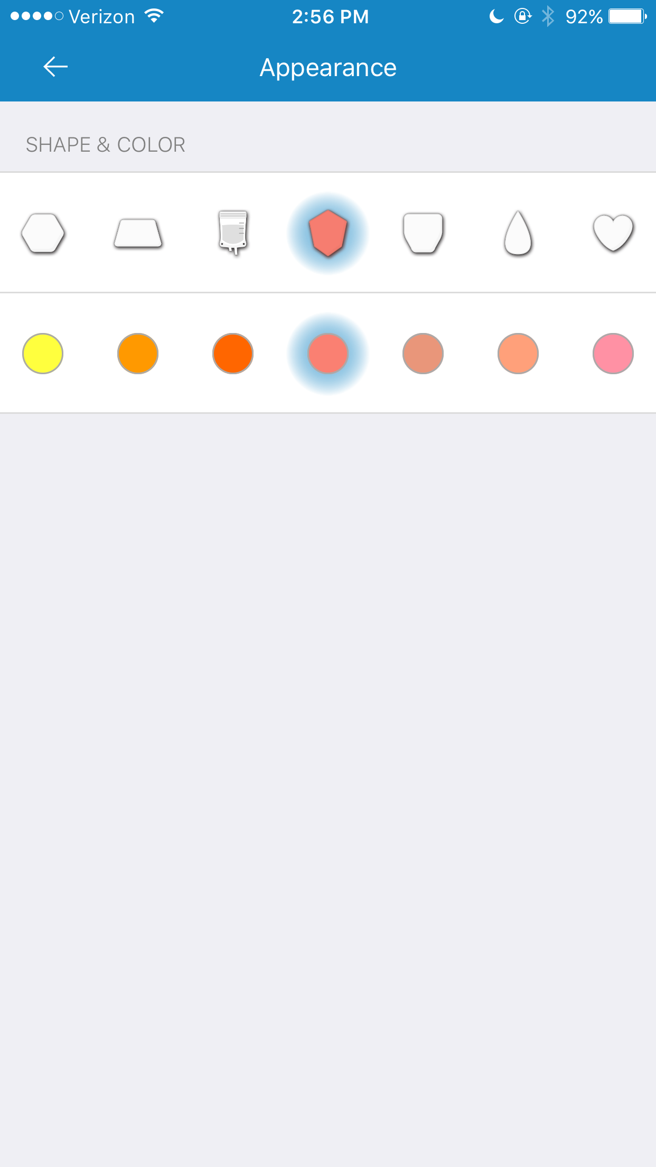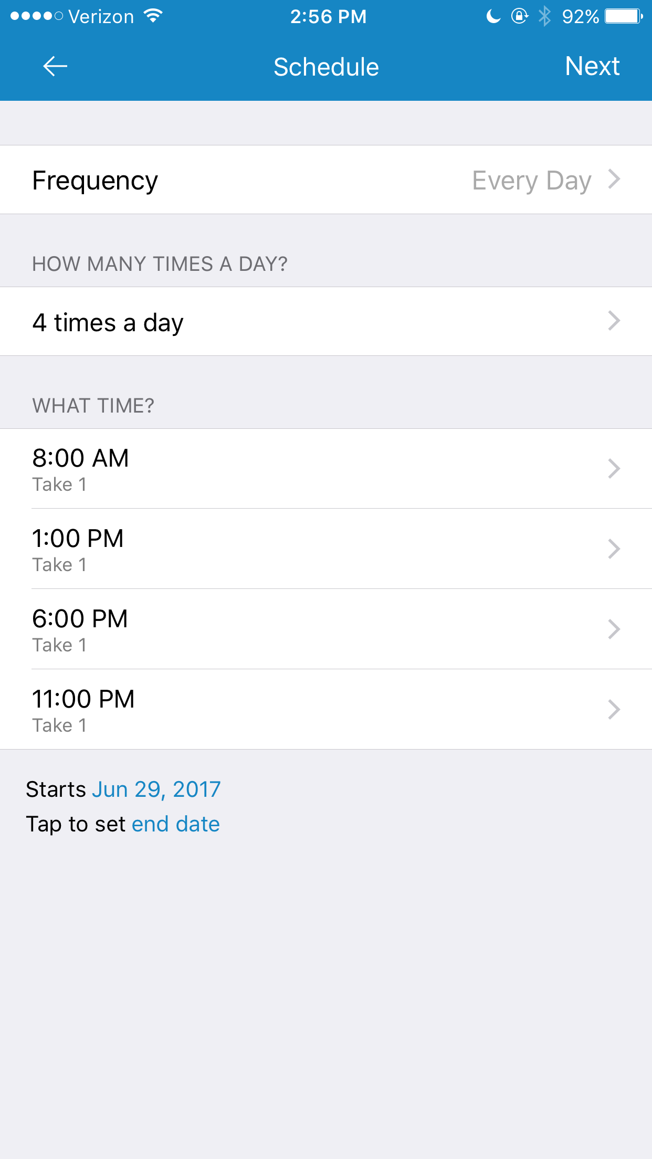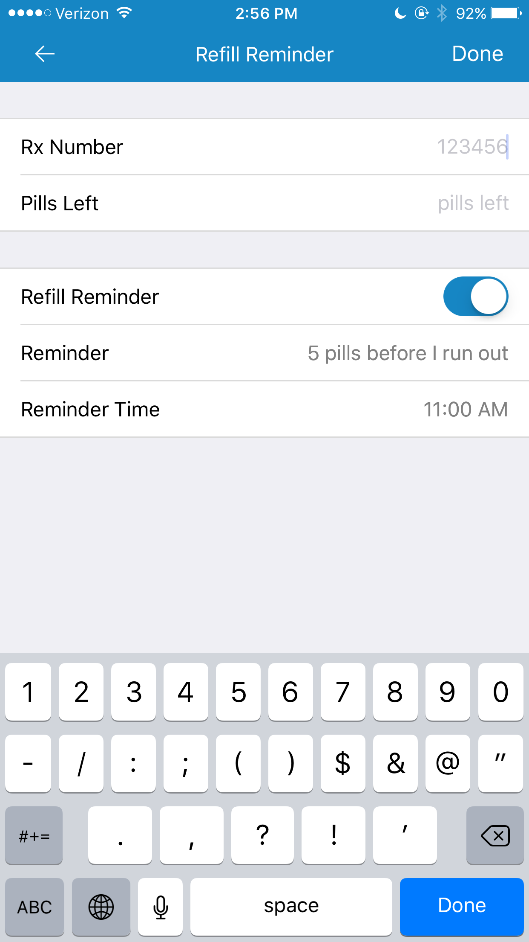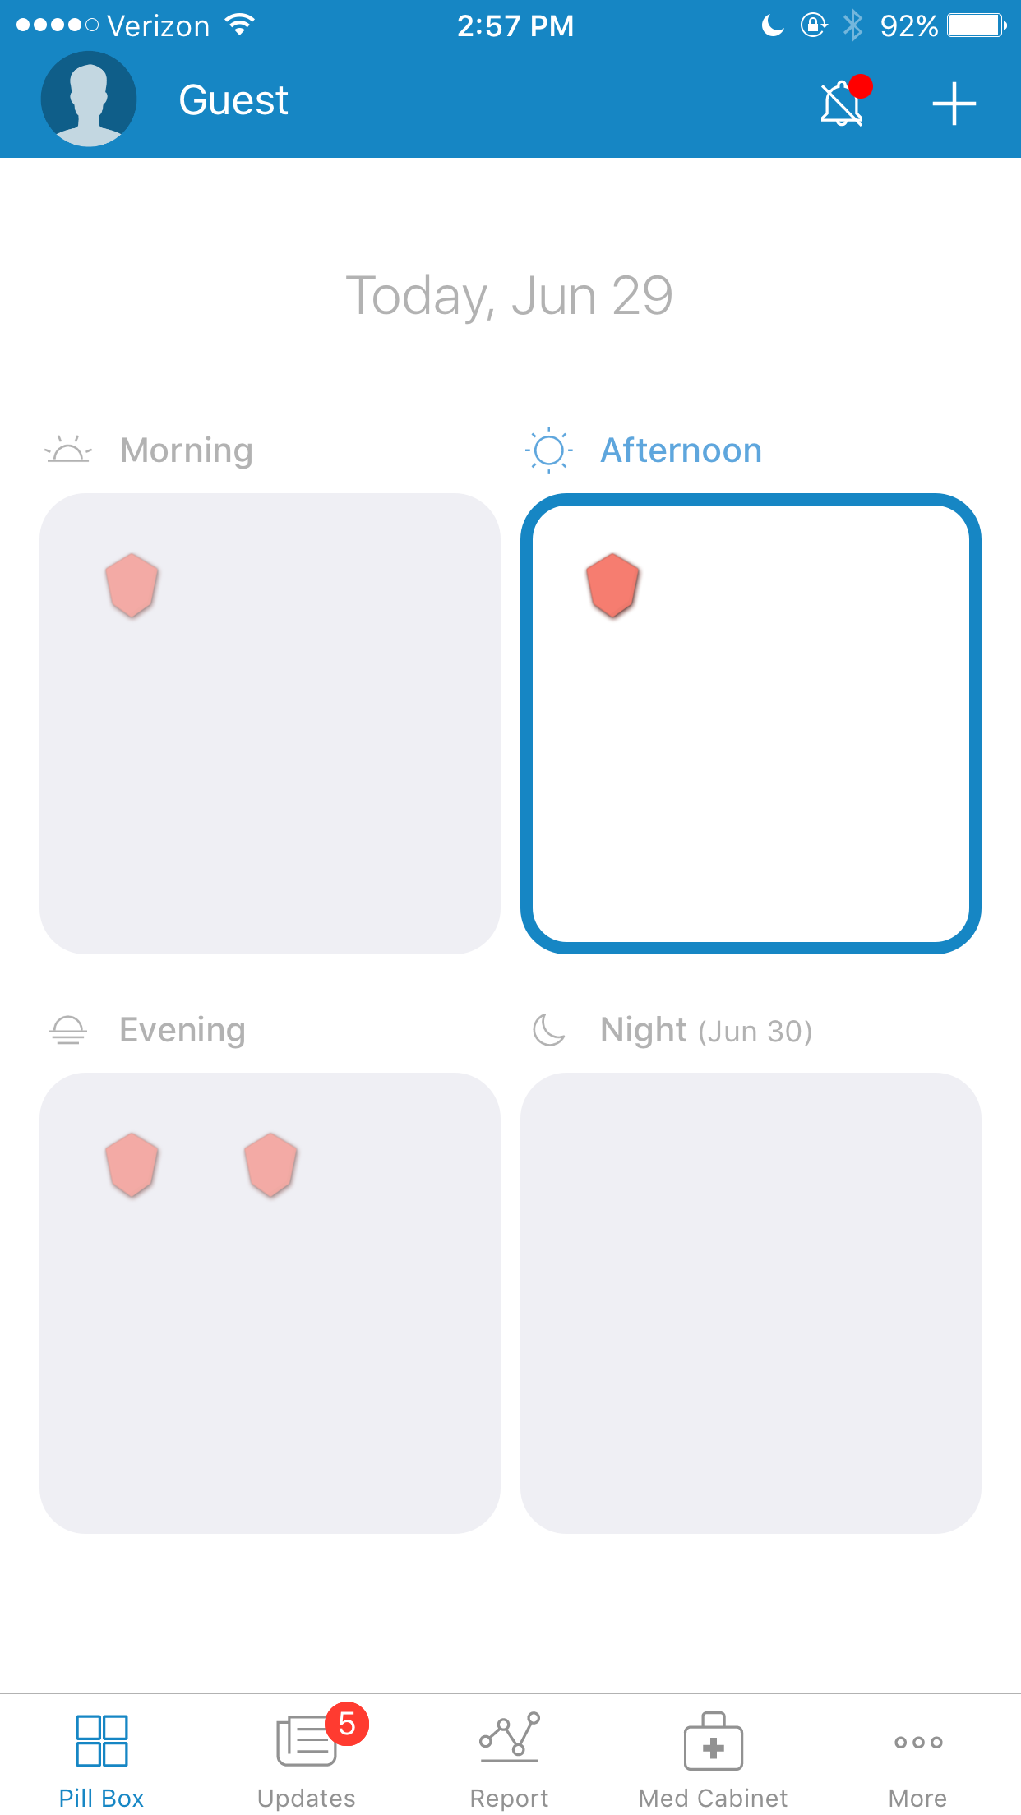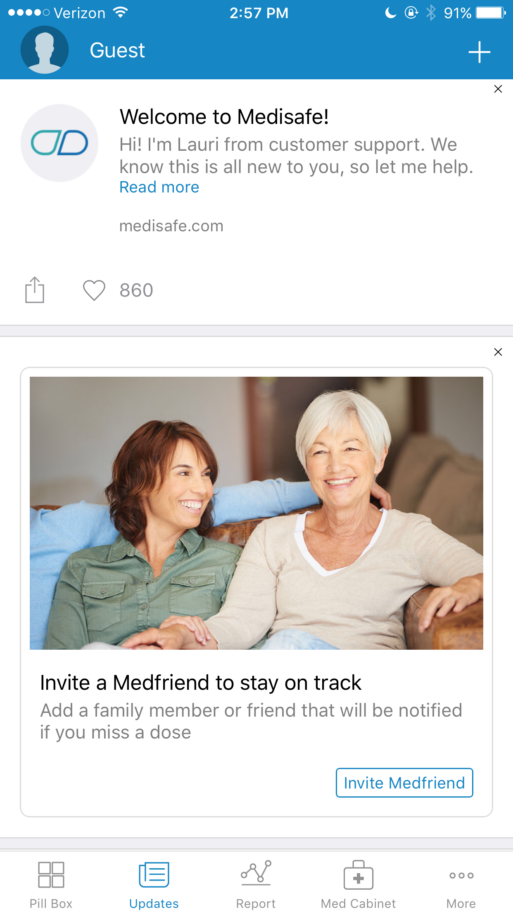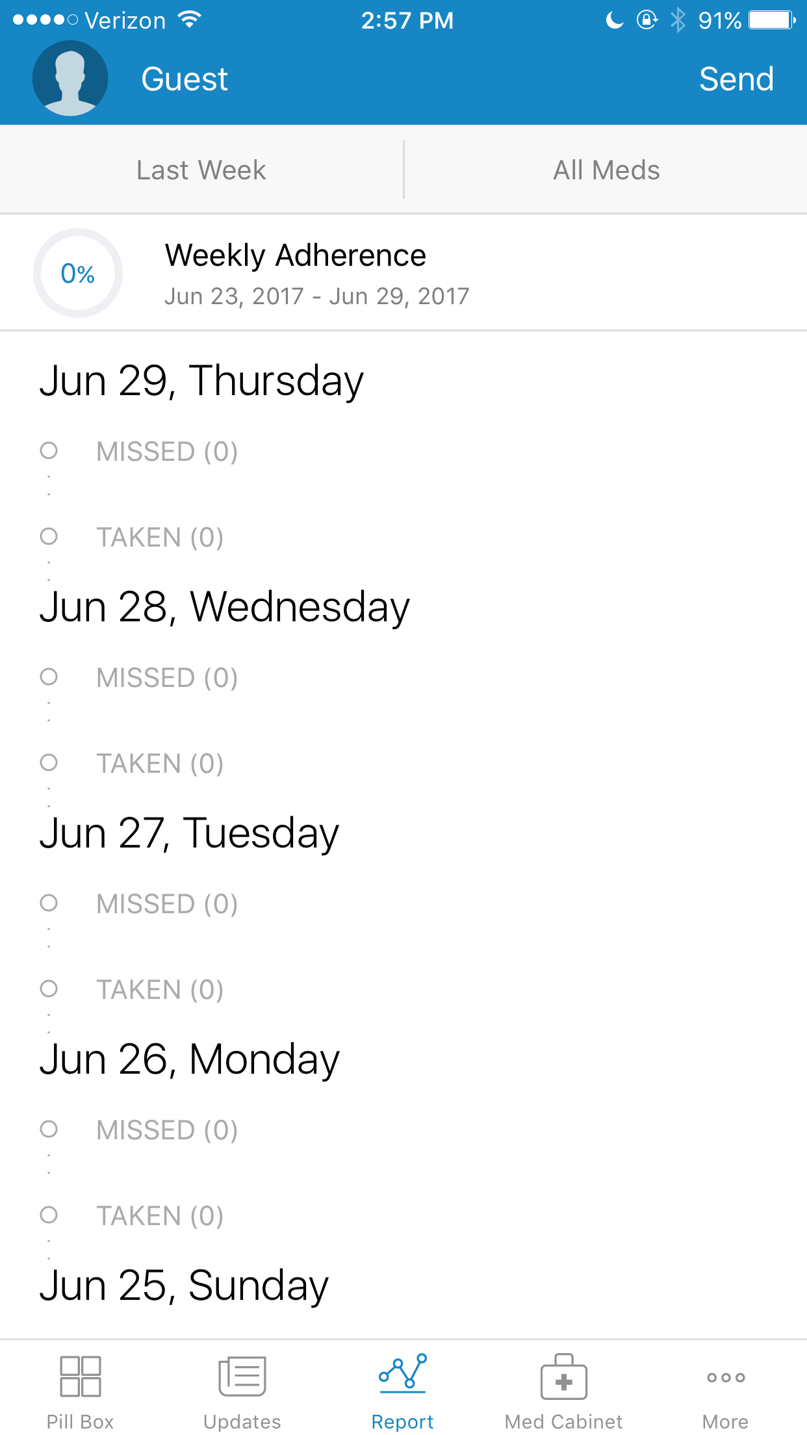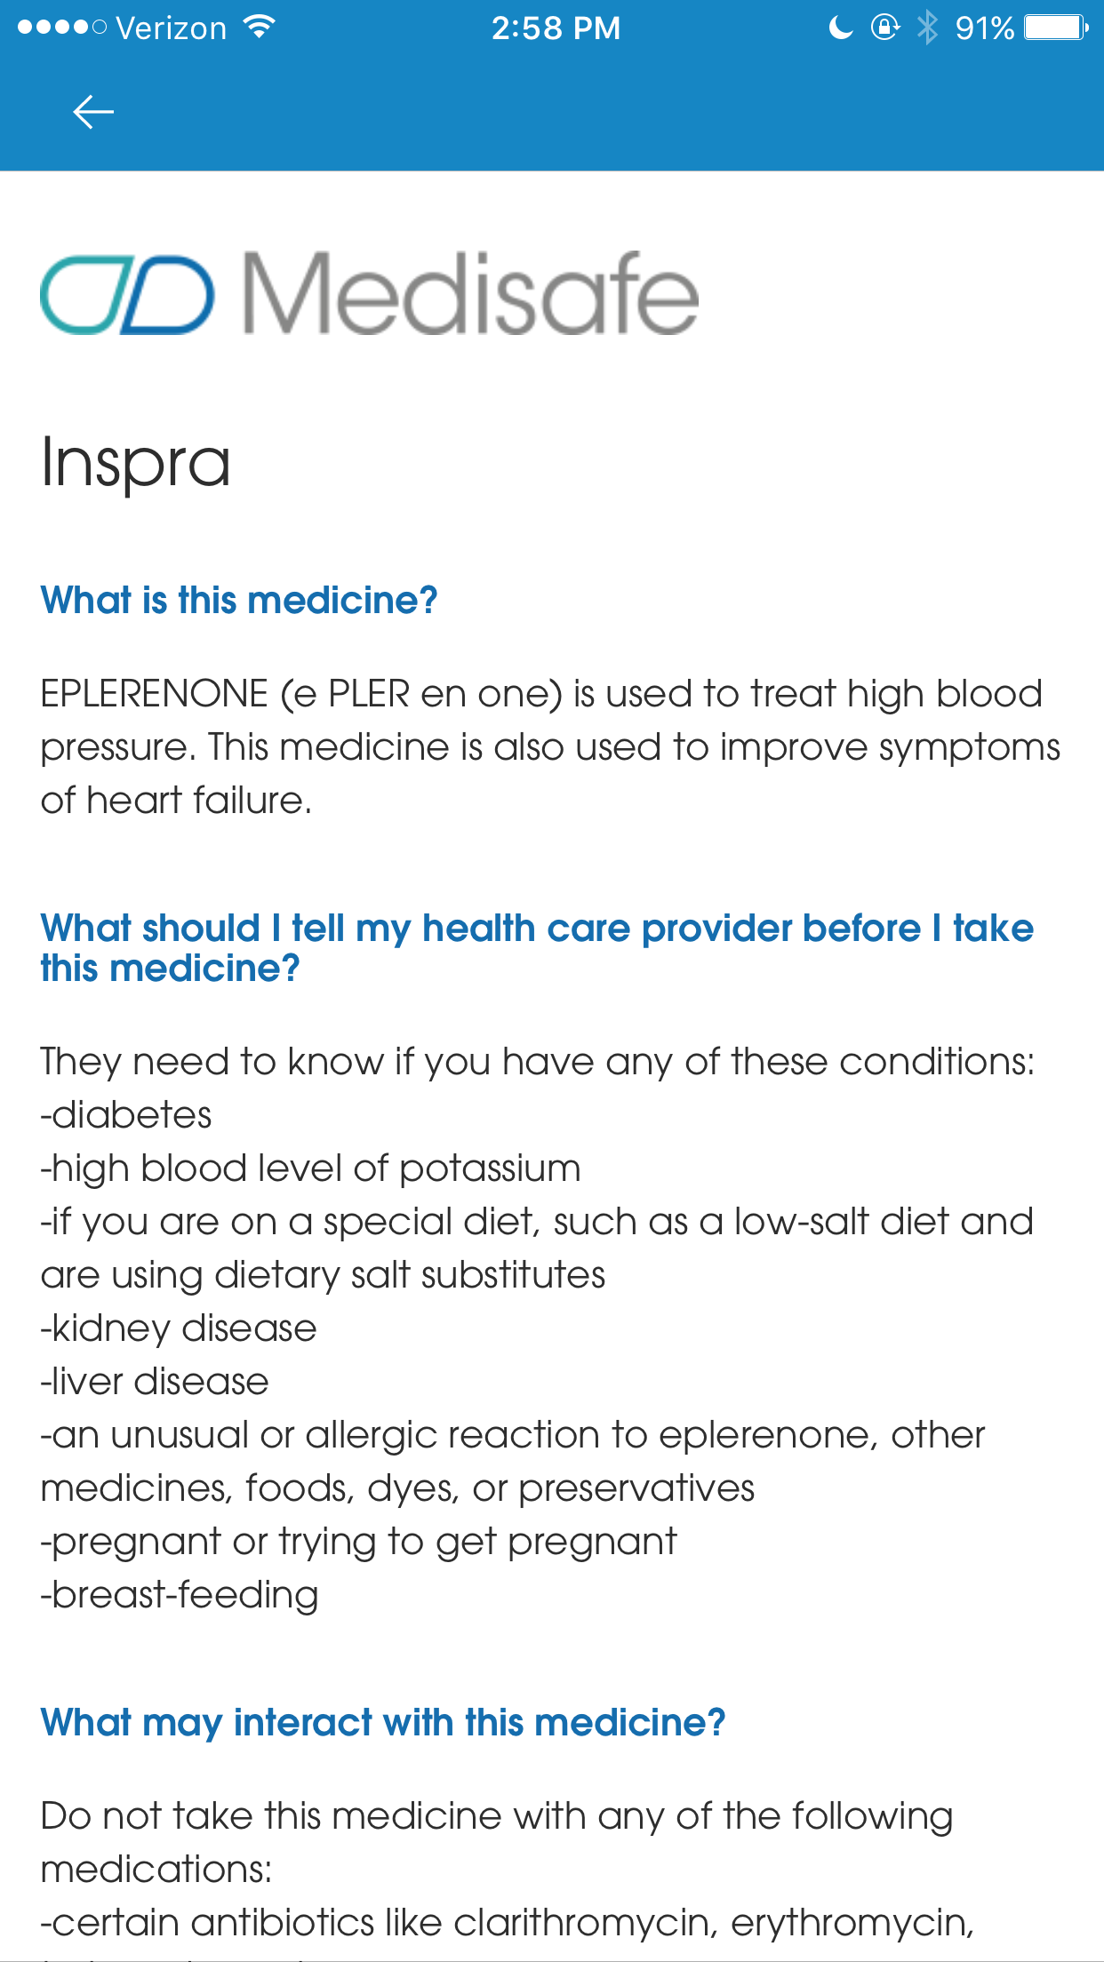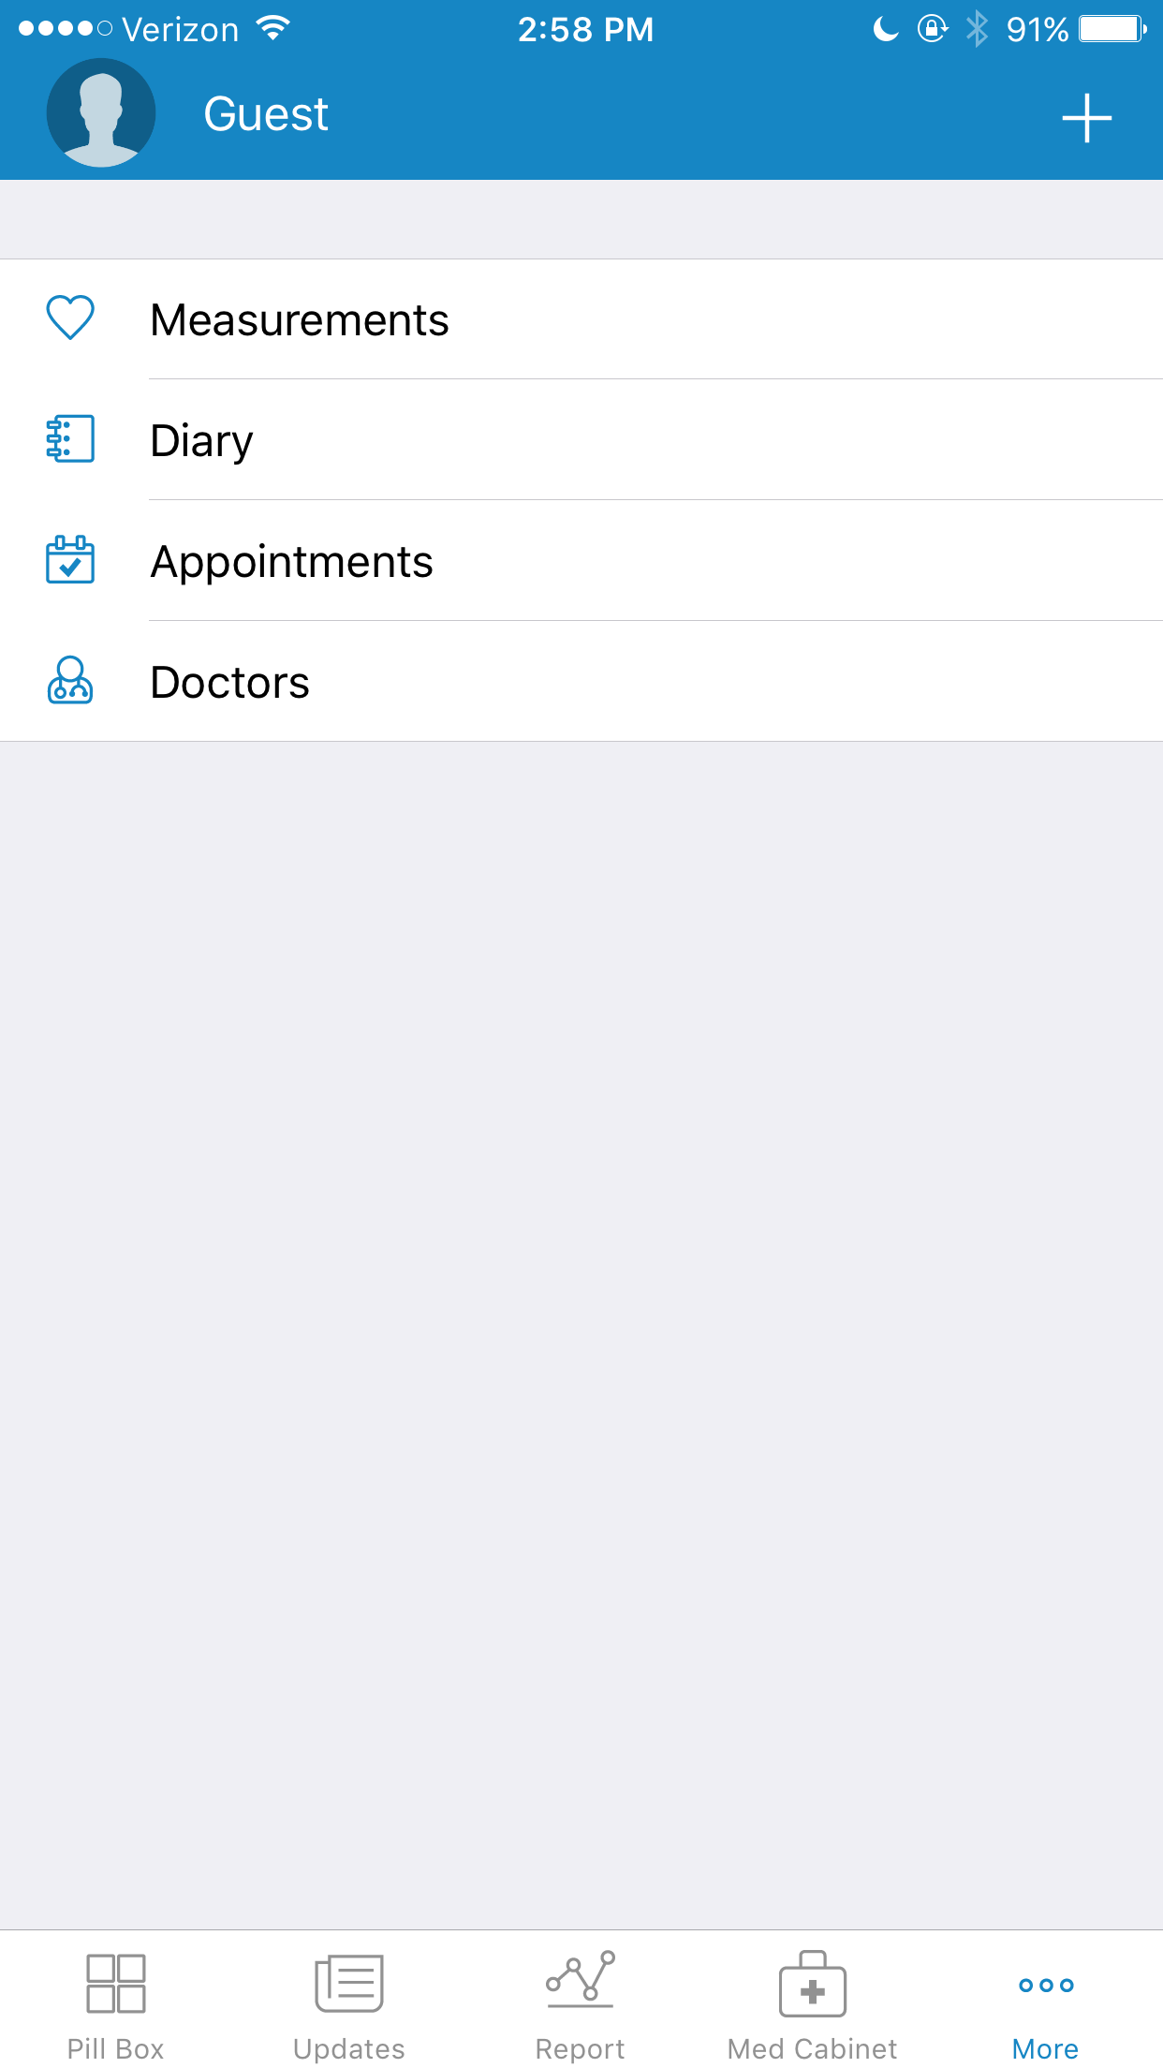

* App enables you to add medication by typing in name (comes up with suggestions as you type), then input dosage and frequency/times taken
* Can also set up refill reminders
* Each med appears in the “pillbox” as an icon (which you can set)
* You get a notification when it is time to take meds (and can snooze notification if needed)
* Can set up contact to be notified if you don’t take the meds
* Monitors adherence
* Allows you to read an article they have about your meds
* Can also track measurements (blood pressure, glucose, etc.), side effects, appointments, and doctors
* Reviews are overwhelmingly positive, this app seems to do everything we want to
* Very user friendly and easy to navigate

**Dosecast - Gabi**

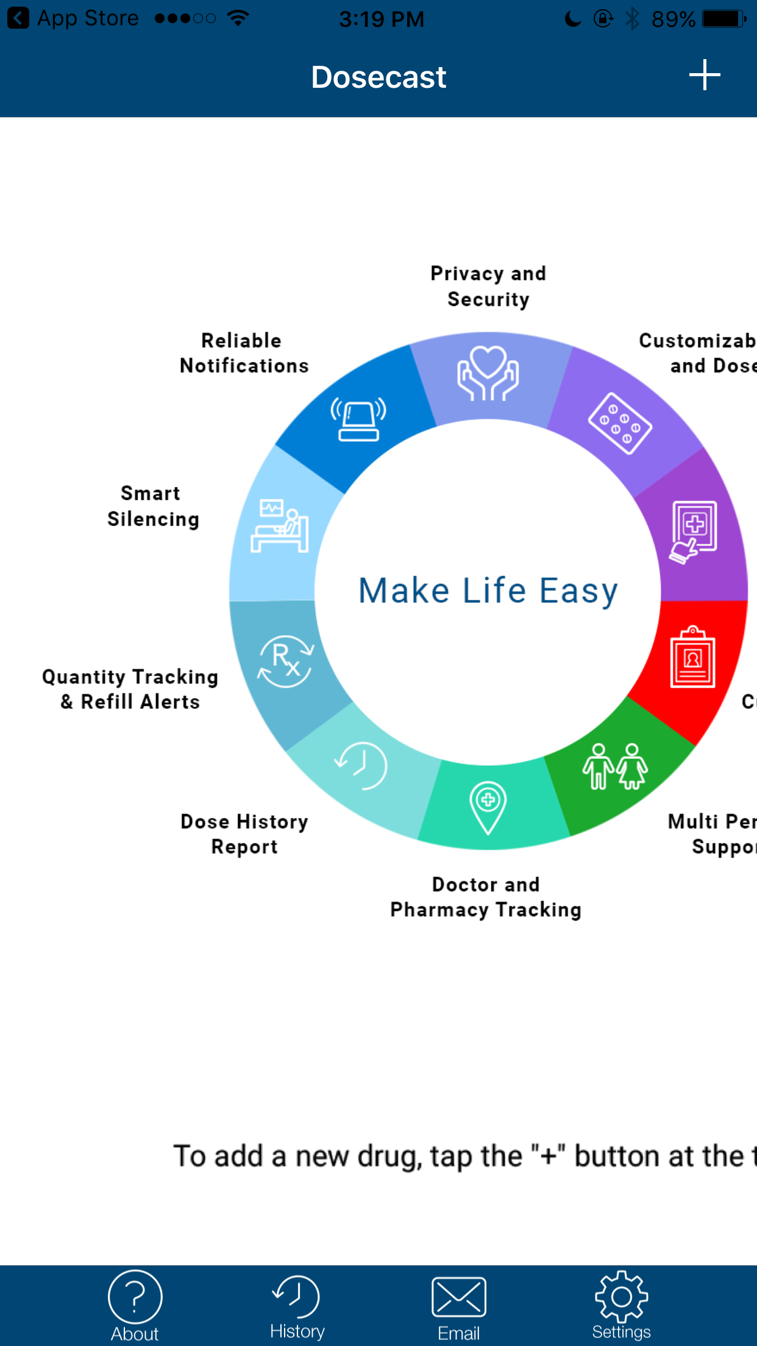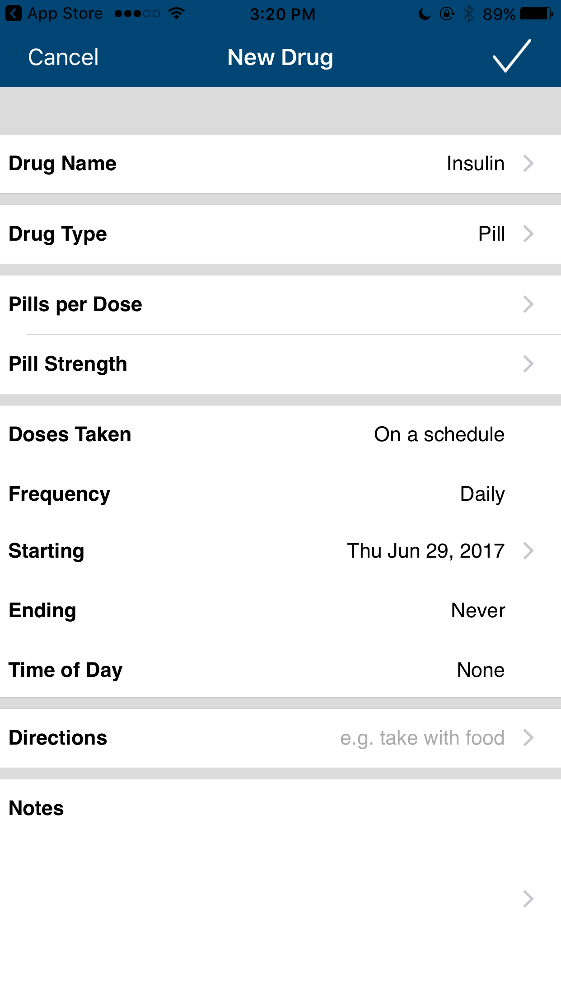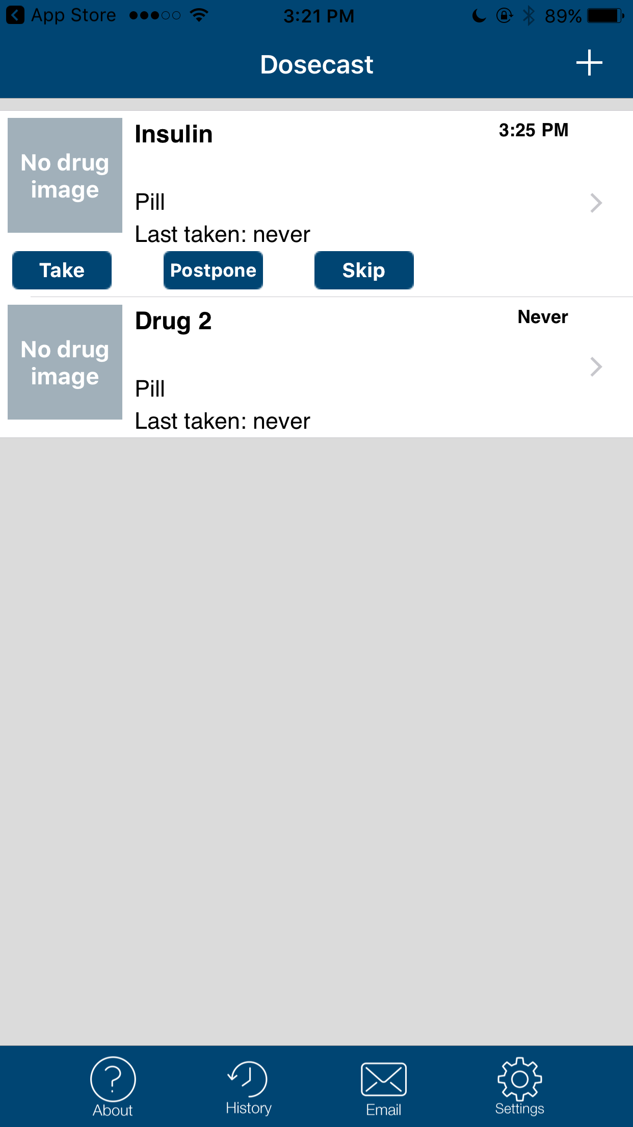

* Could add medication manually
  + Could only search medication from database if you upgraded to pro
* Could modify features
  + Some, like non pill drugs, only available in pro
* Medication history only for pro
* Somewhat positive reviews
* May be matter if upgraded to pro, but basic doesn’t have a lot of features
* No way to set contacts or track other health aspects
* Not very design friendly / aesthetically pleasing

**MedHelper-Sergio**

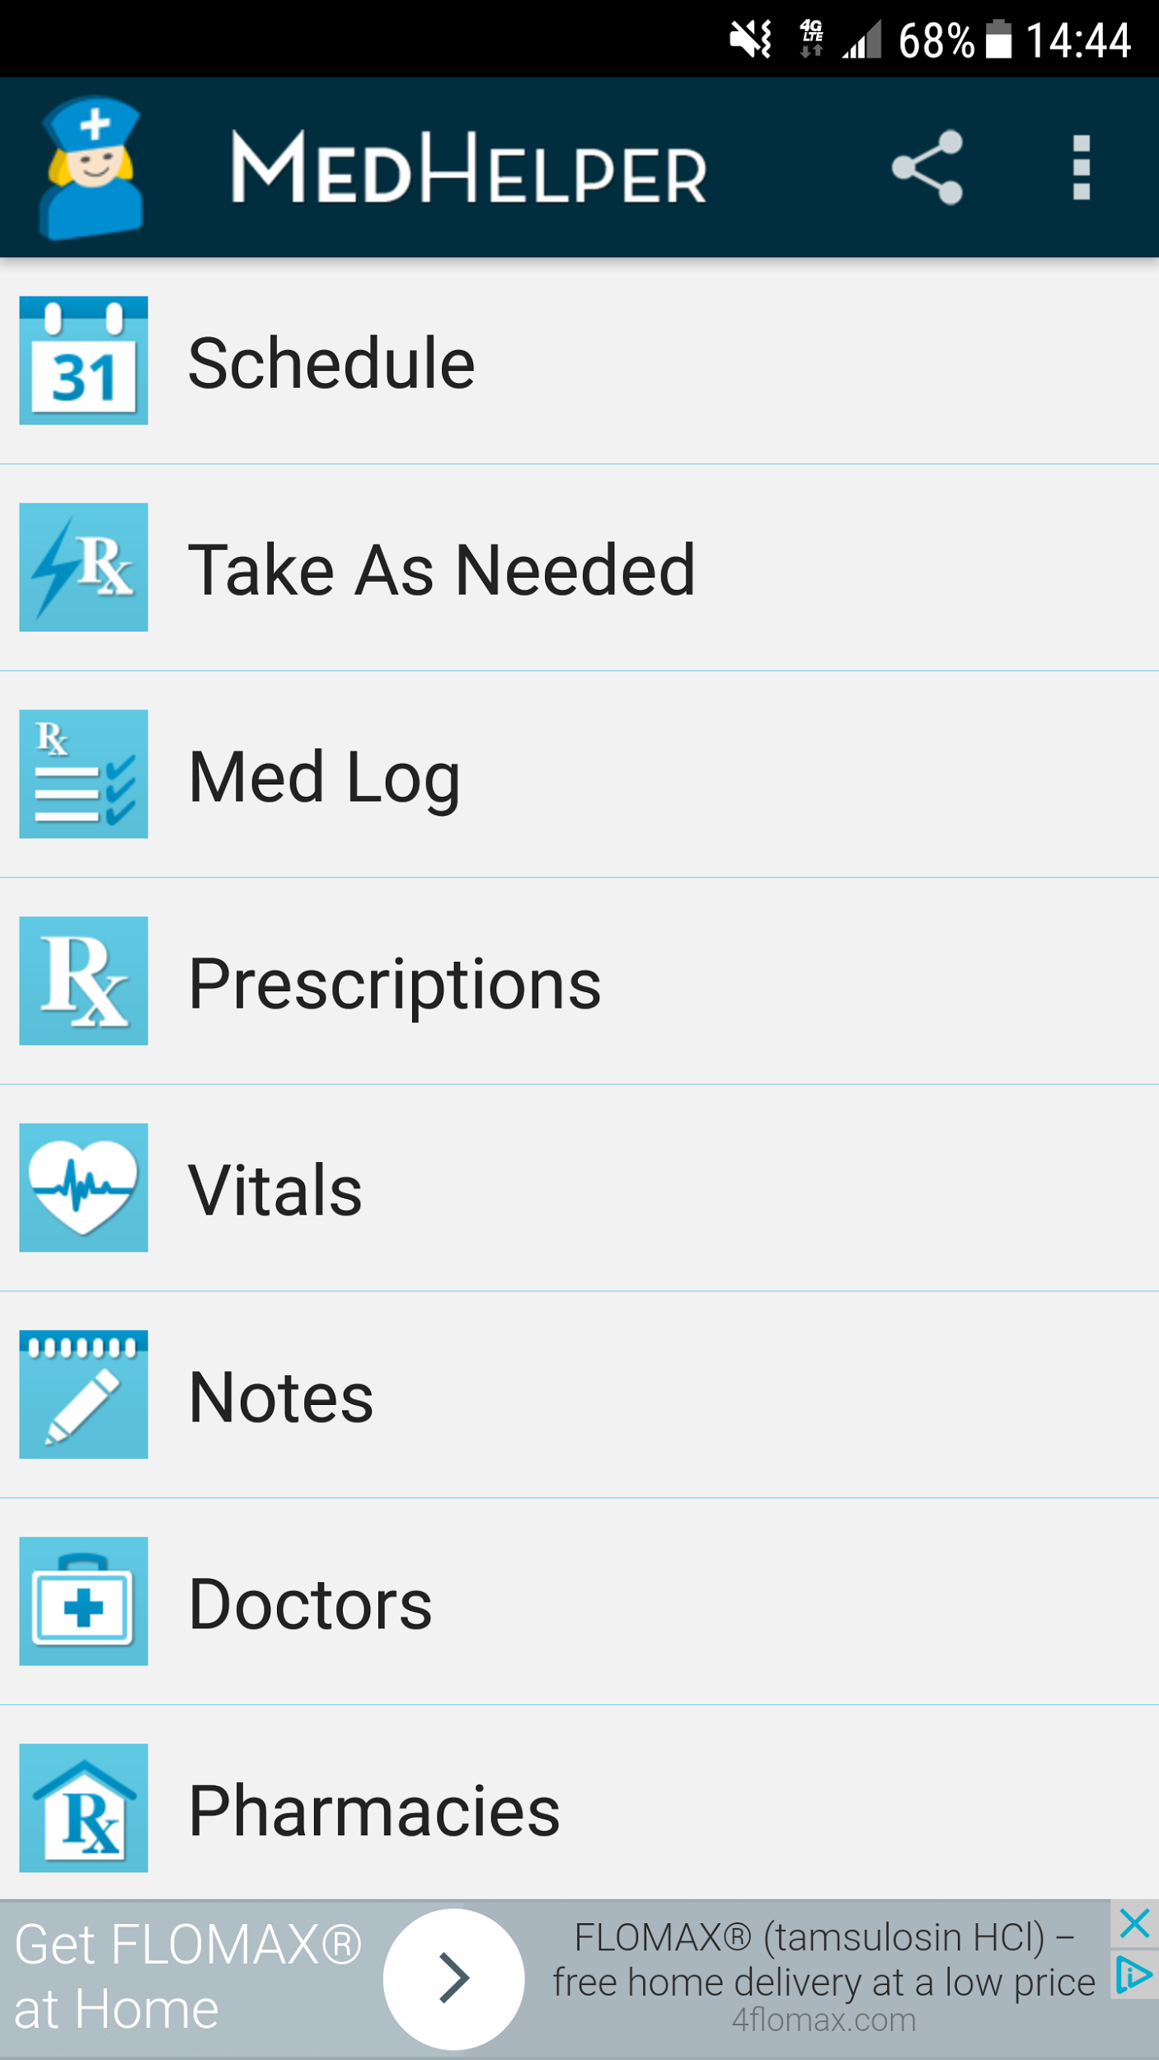

* Available in iOS and Android, it has a website with tutorials and manuals for each platform
* Patients can log meds they take and add them to schedule so they get notifications when they have to take them.
* Patients can add appointments and they get notifications.
* Patients can log prescriptions, the lists of doctors they see, and the list of pharmacies they use, and assign each prescription to the doctor that prescribed it and to the pharmacy they want to pick it up.
* Under Vitals, patients can record their vital signals every day, and they can filter by date or by sign when they want to go back and check
* This app looks very helpful for medication management and medical routine in general
* Very well organized and looks easy to use. Everything is pretty straight forward and is well documented.

**My PillBox-Sergio**

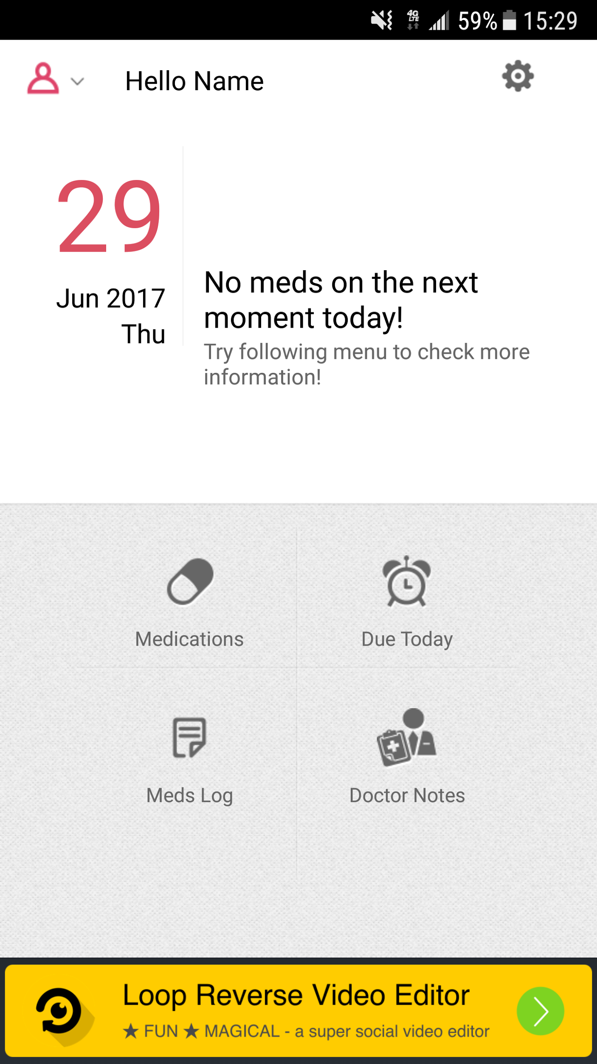

* Clean interface
* Patients can log a medication, and assign it a color and an icon that relates to the medication
* Patient can add doctor’s notes
* Patients get notifications when they have to take the meds.
* This app has potential for more features, but at the moment it doesn’t offer anything unique, it’s just very simple to use which can be appealing to some patients.

**CareZone-Sergio**

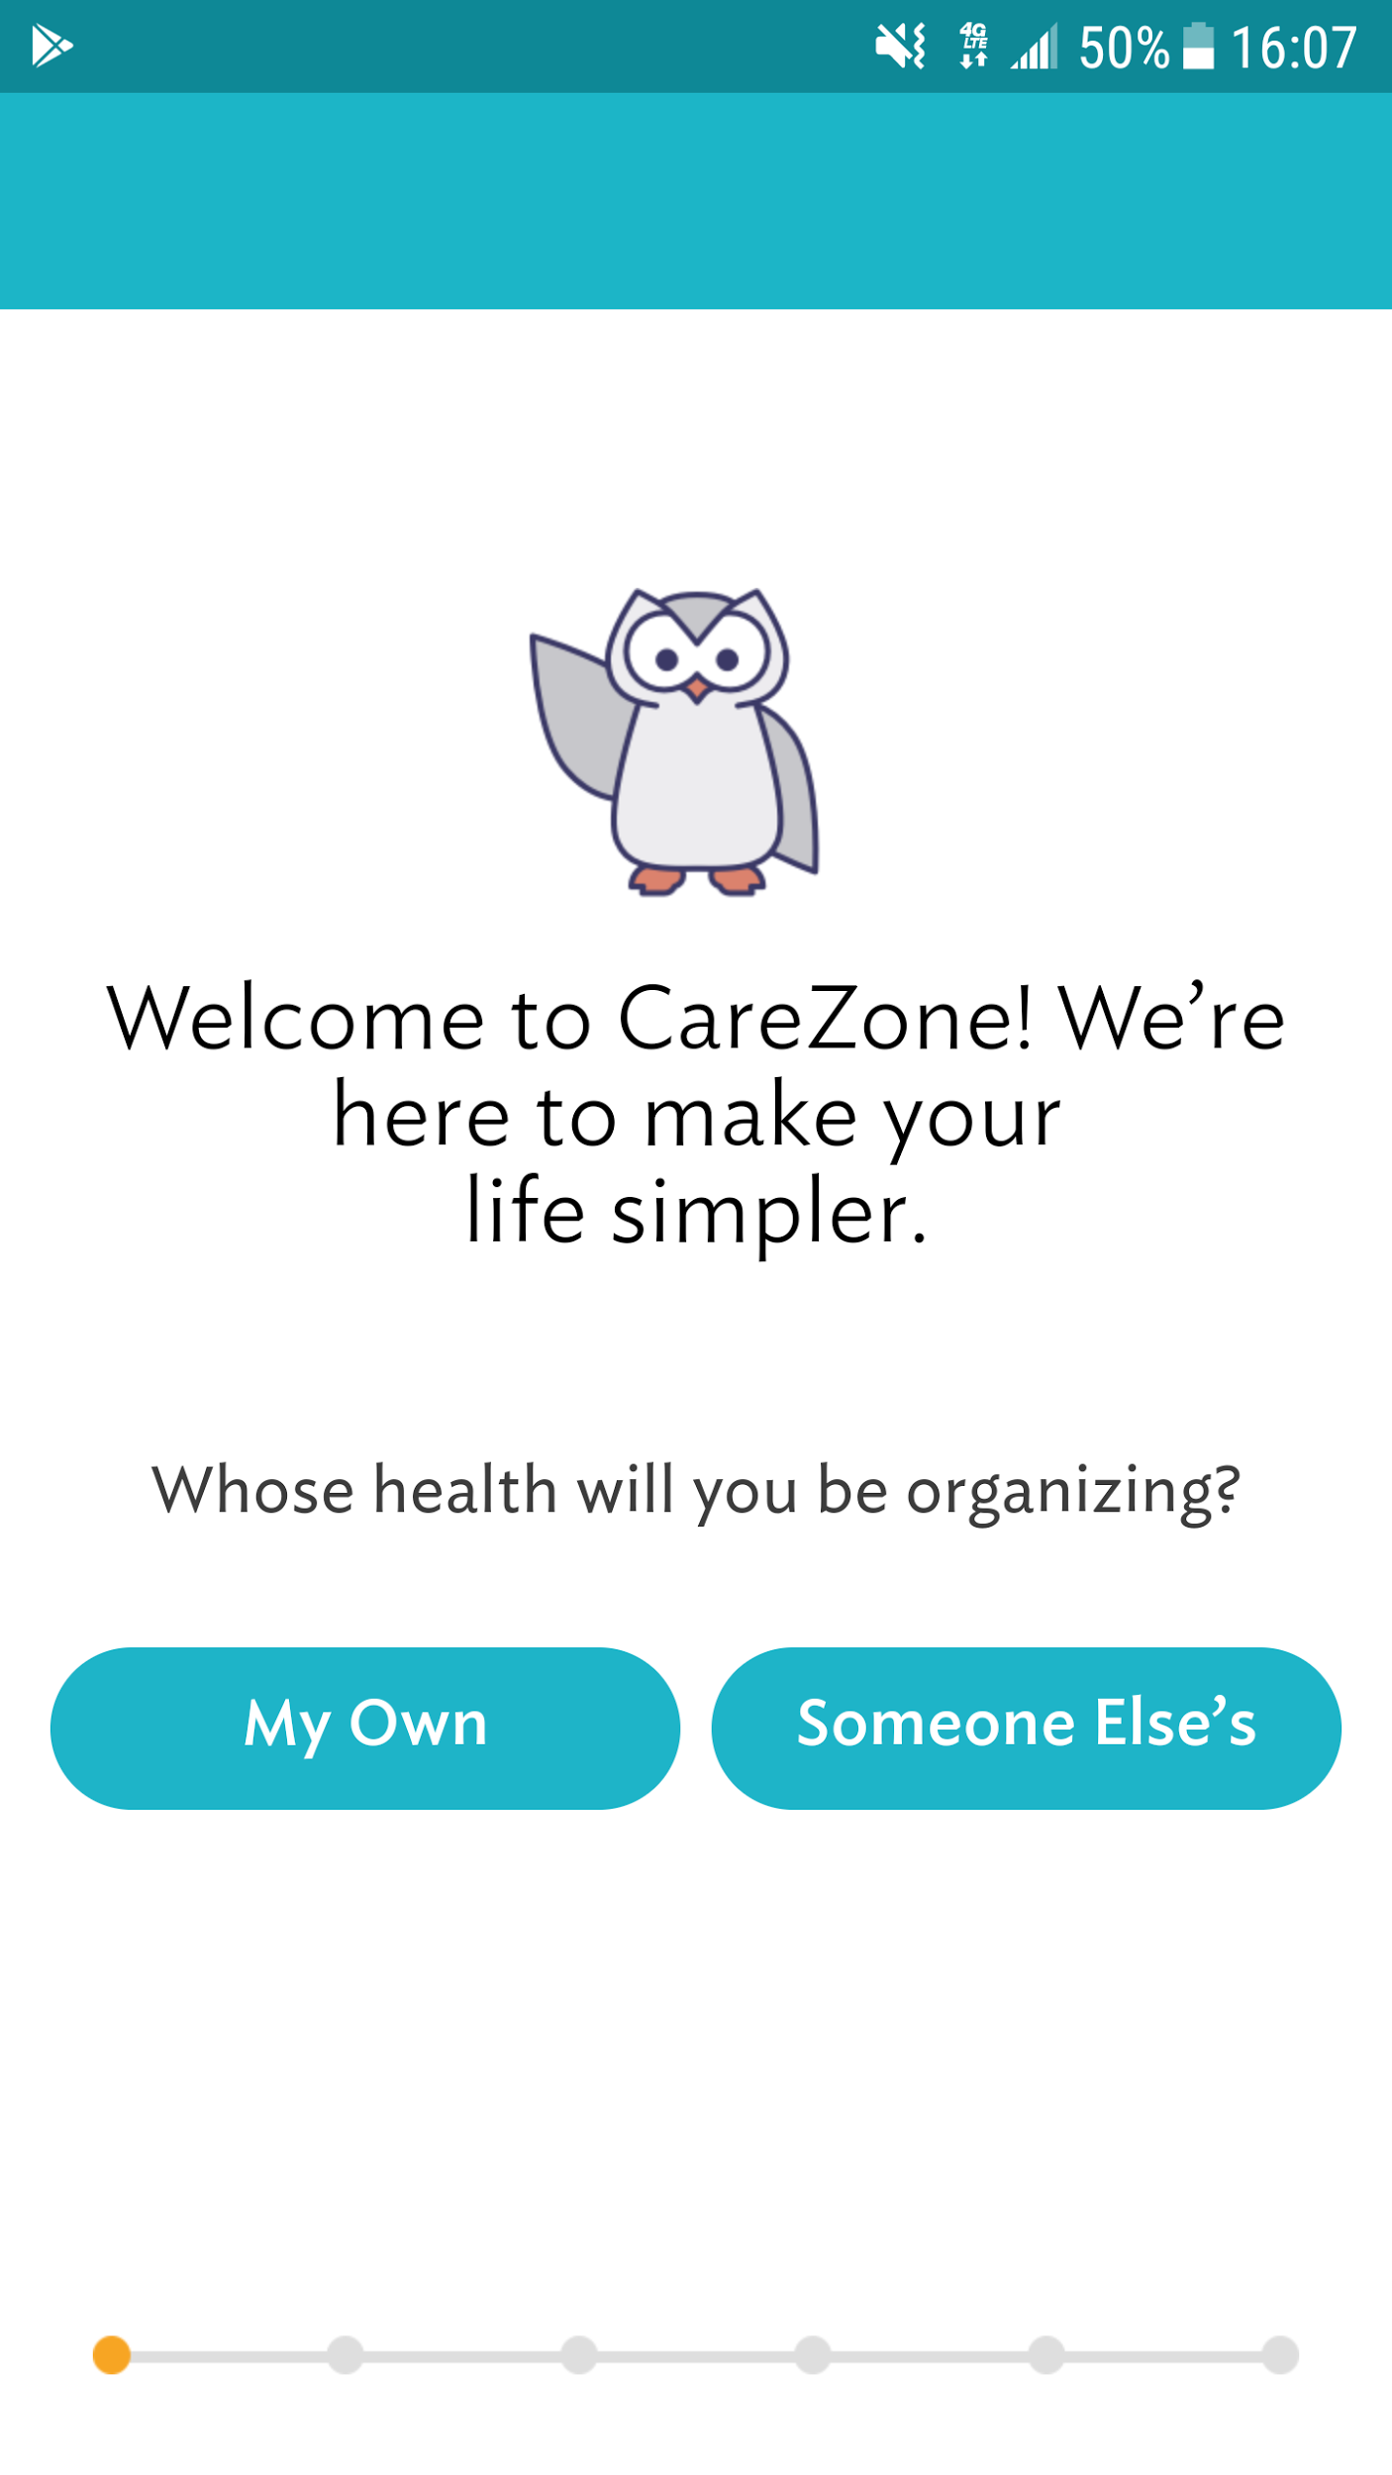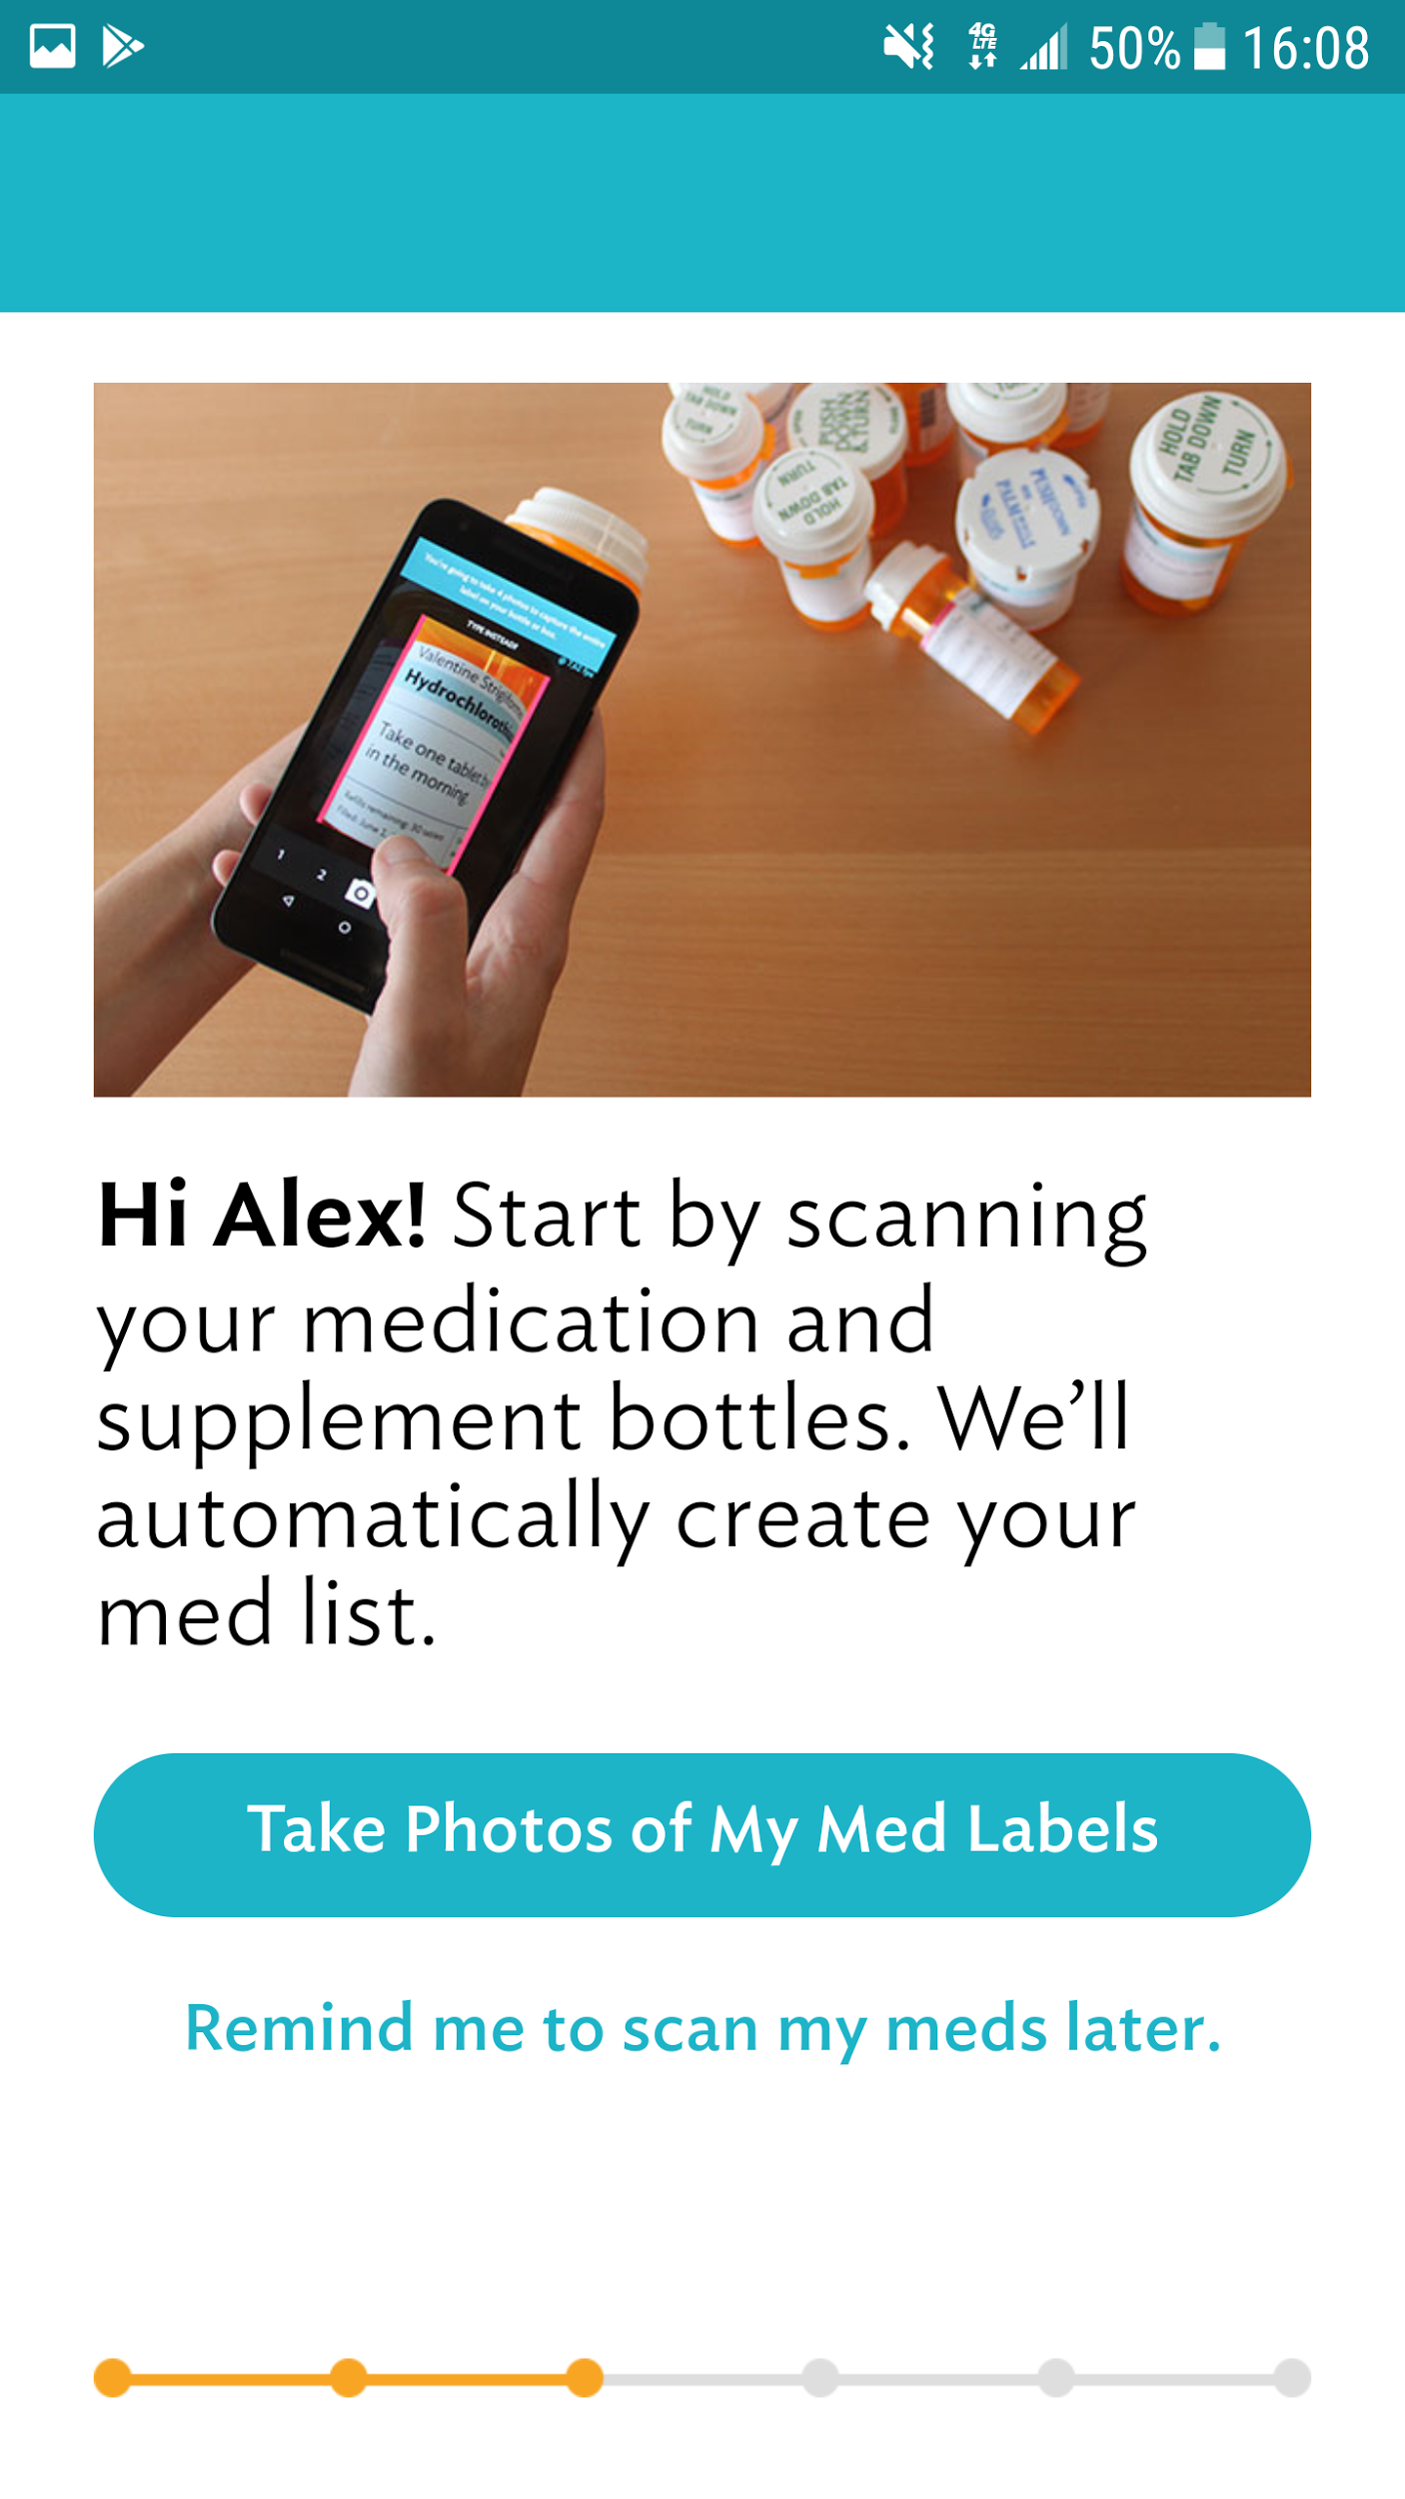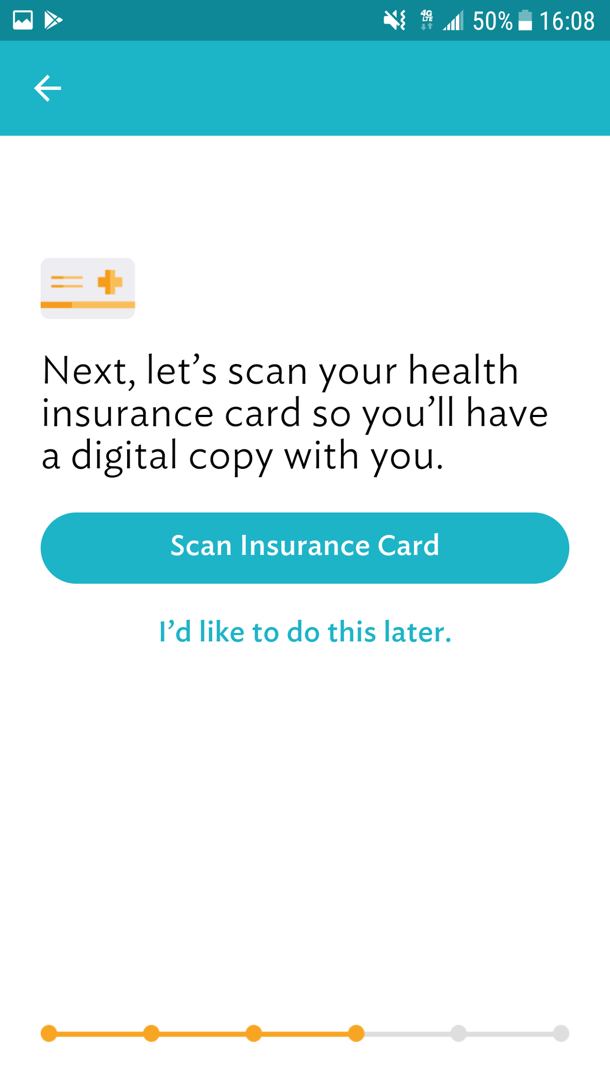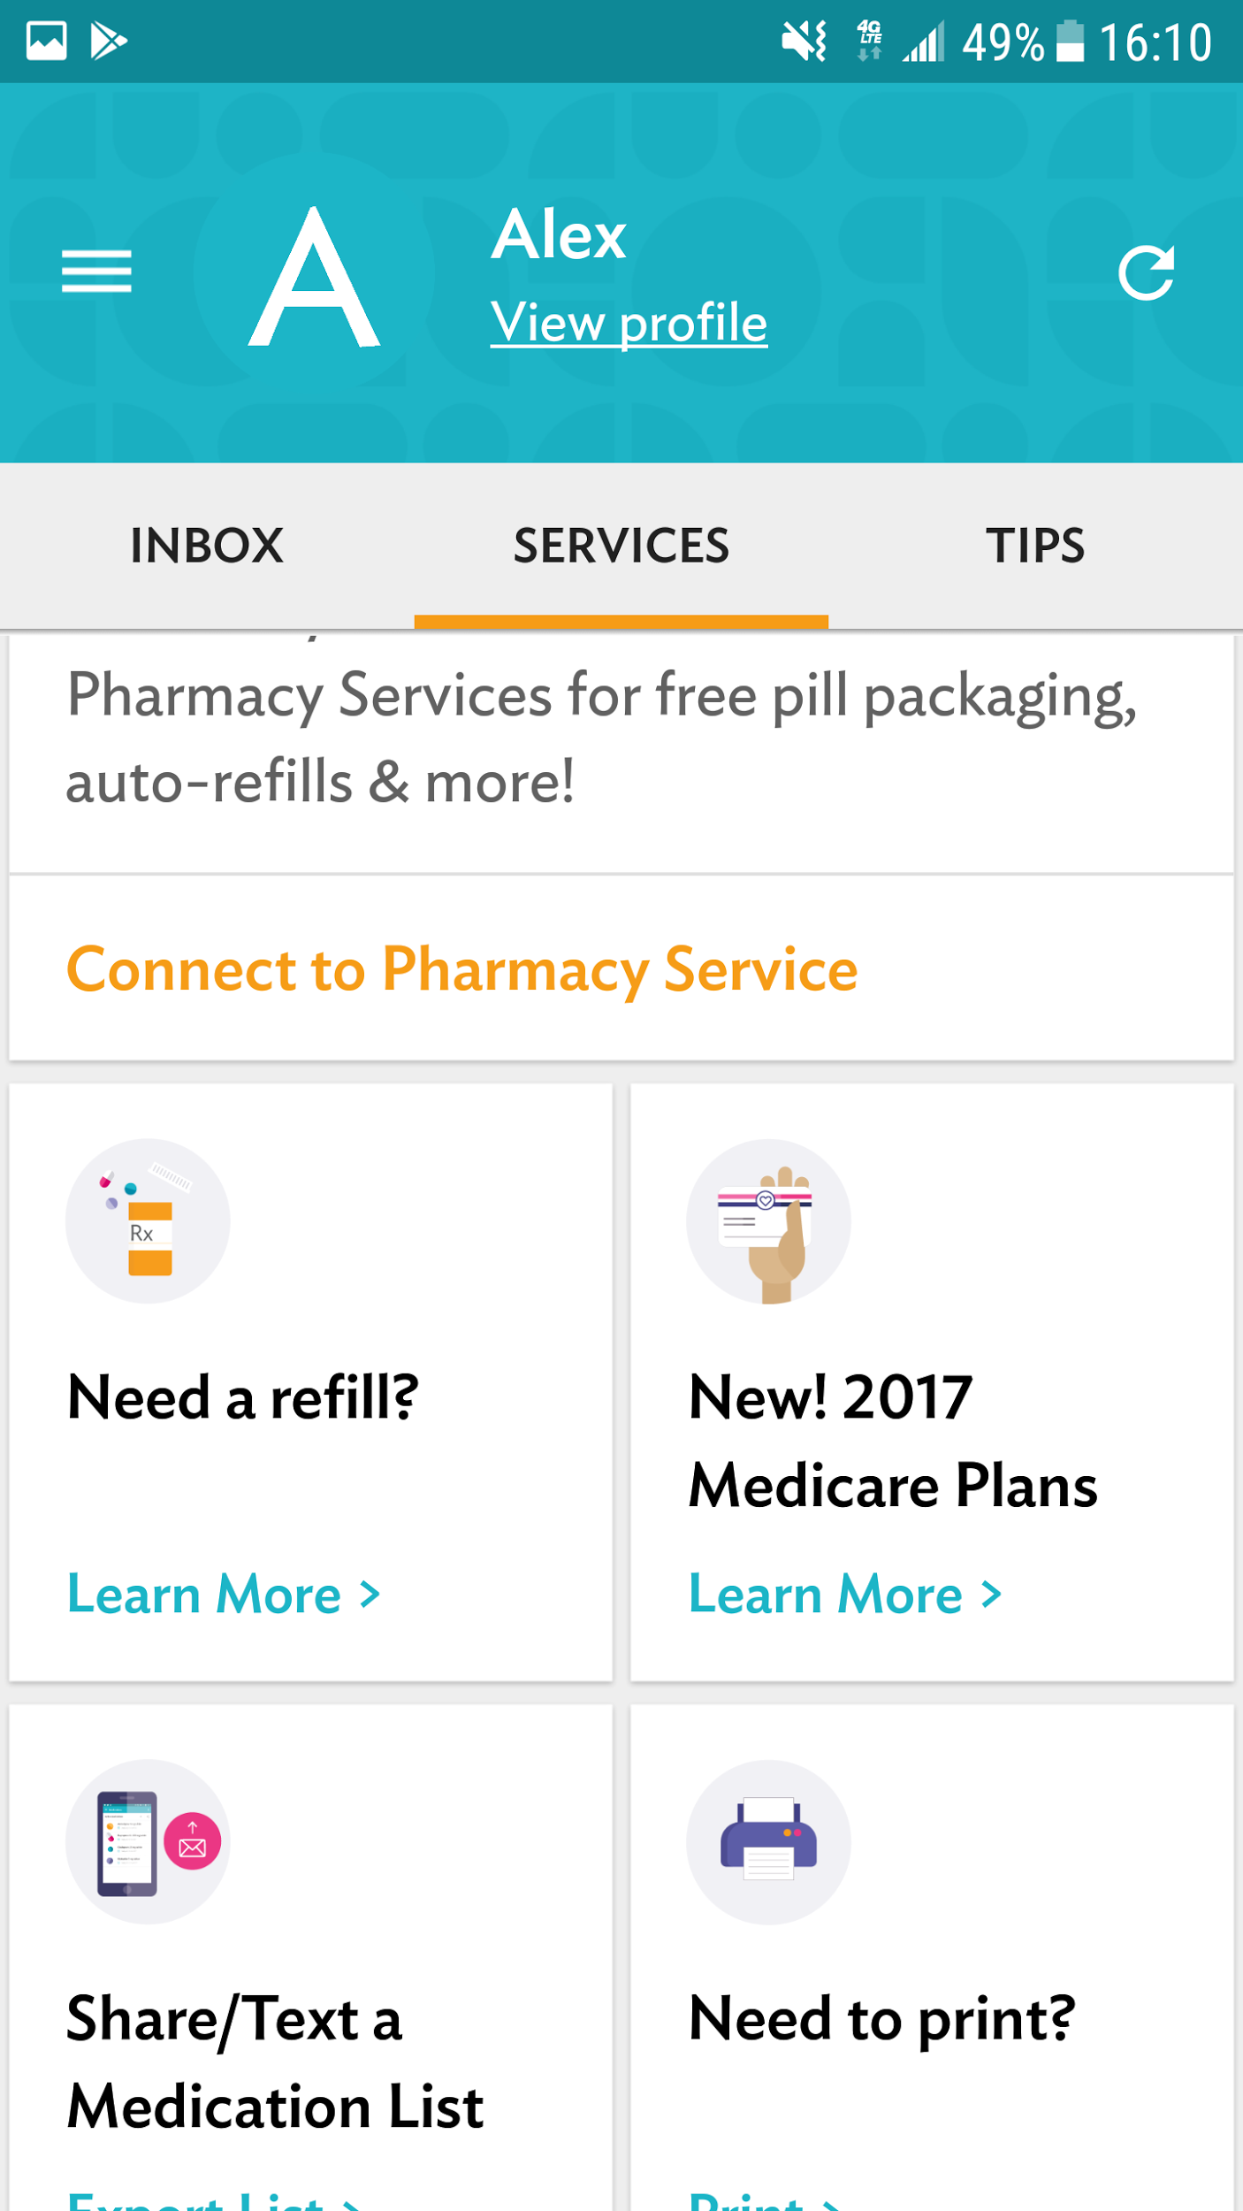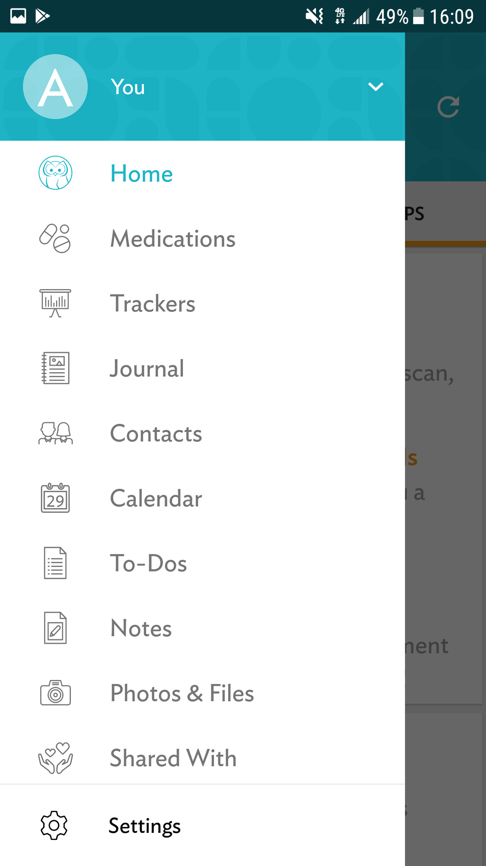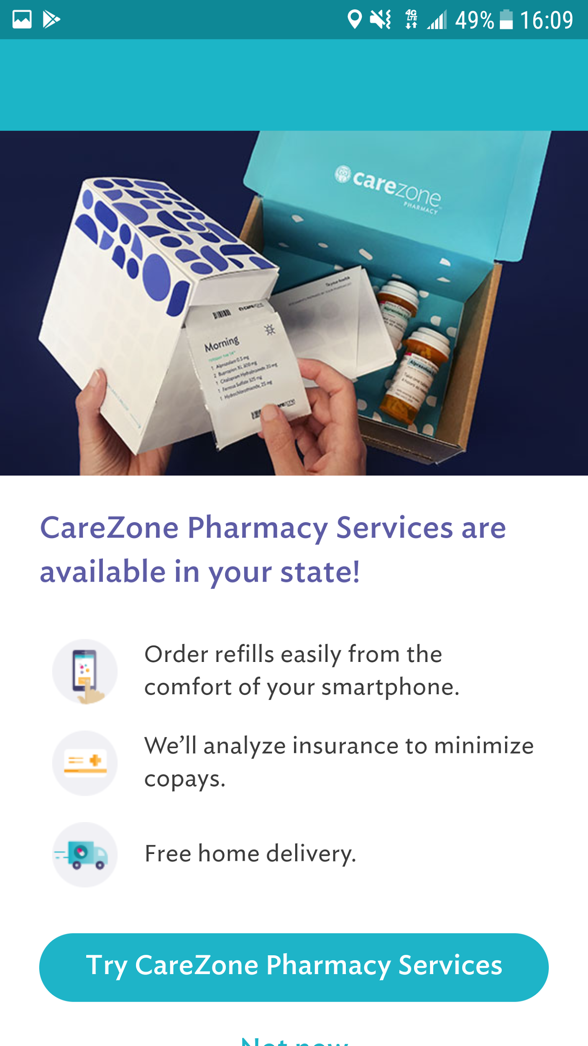

* Patients can very easily log their meds by taking a picture of the bottle
* Patients can take a picture of the health insurance cards, and they don’t have to carry it anymore
* Patients can decide what to track, from blood glucose, blood pressure, pain, headache, mood, body temperature, sleep, nausea, weight, seizure, blood oxygenation, height, HIV counts
* Patients can add photos and files that may be related to their health.
* Patients can share all these information with other people such as family members or healthcare providers.
* The app offer pharmacy services
* This app is extremely helpful, but some patients may take a long time to understand all the features.

**Mango Health-Sergio**

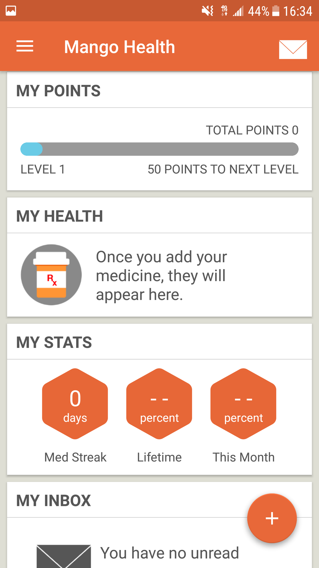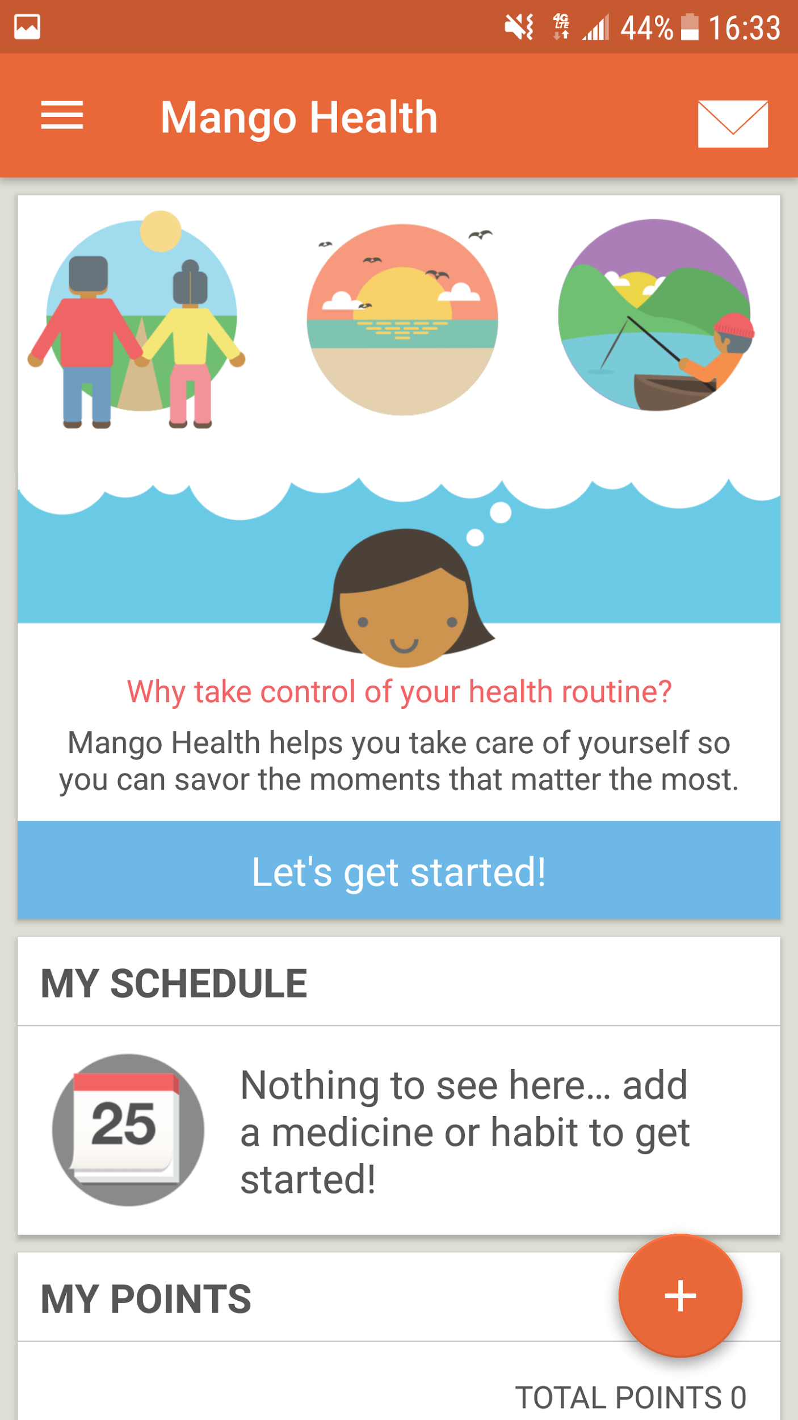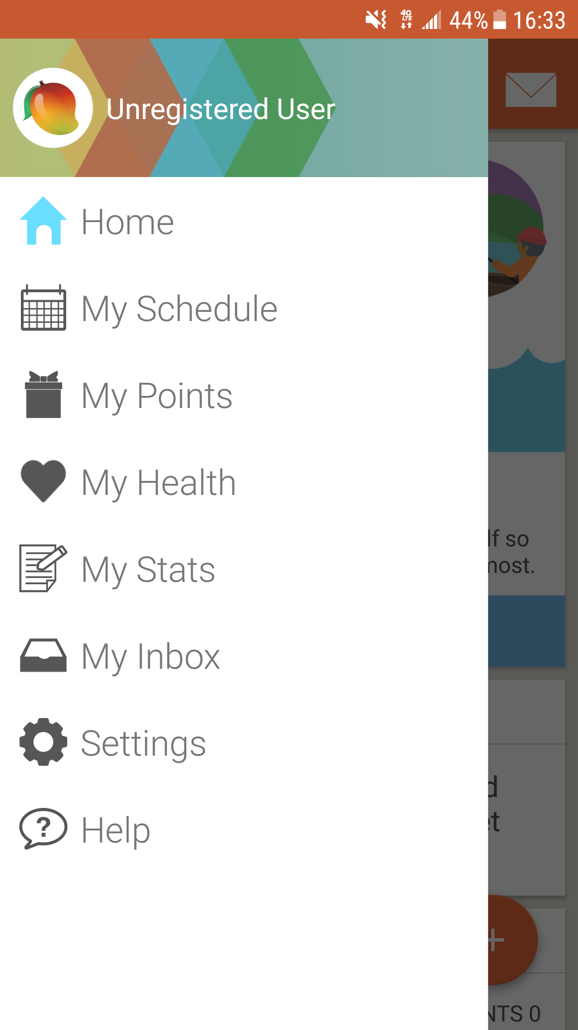

* This app is super friendly
* Patients can log their meds and the app reminds them when they have to take them
* Patients can build habits such as hydrating, checking blood glucose, etc.
* Patients accumulate points based on how obedient they are with their beds, and after reaching a certain number of points they pass to another level; it’s like a game, fun.
* The interface is very likable.

**Glucose Buddy-Sergio**

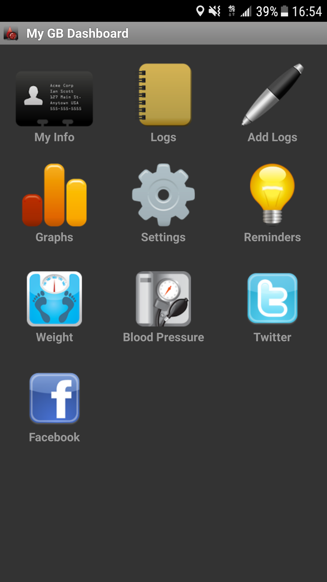

* The app Homepage is very to the point, which is good for some patients.
* Patients can log their blood glucose, carbs, medication, activities, A1C, blood pressure, and weight.
* App has link to their Facebook and Twitter pages, where there are constant streams of advices and strategies such as diets and exercise routines to manage the patient’s health.
* Patients can set reminders to take meds or do other activities.

**Iodine - Gabi**

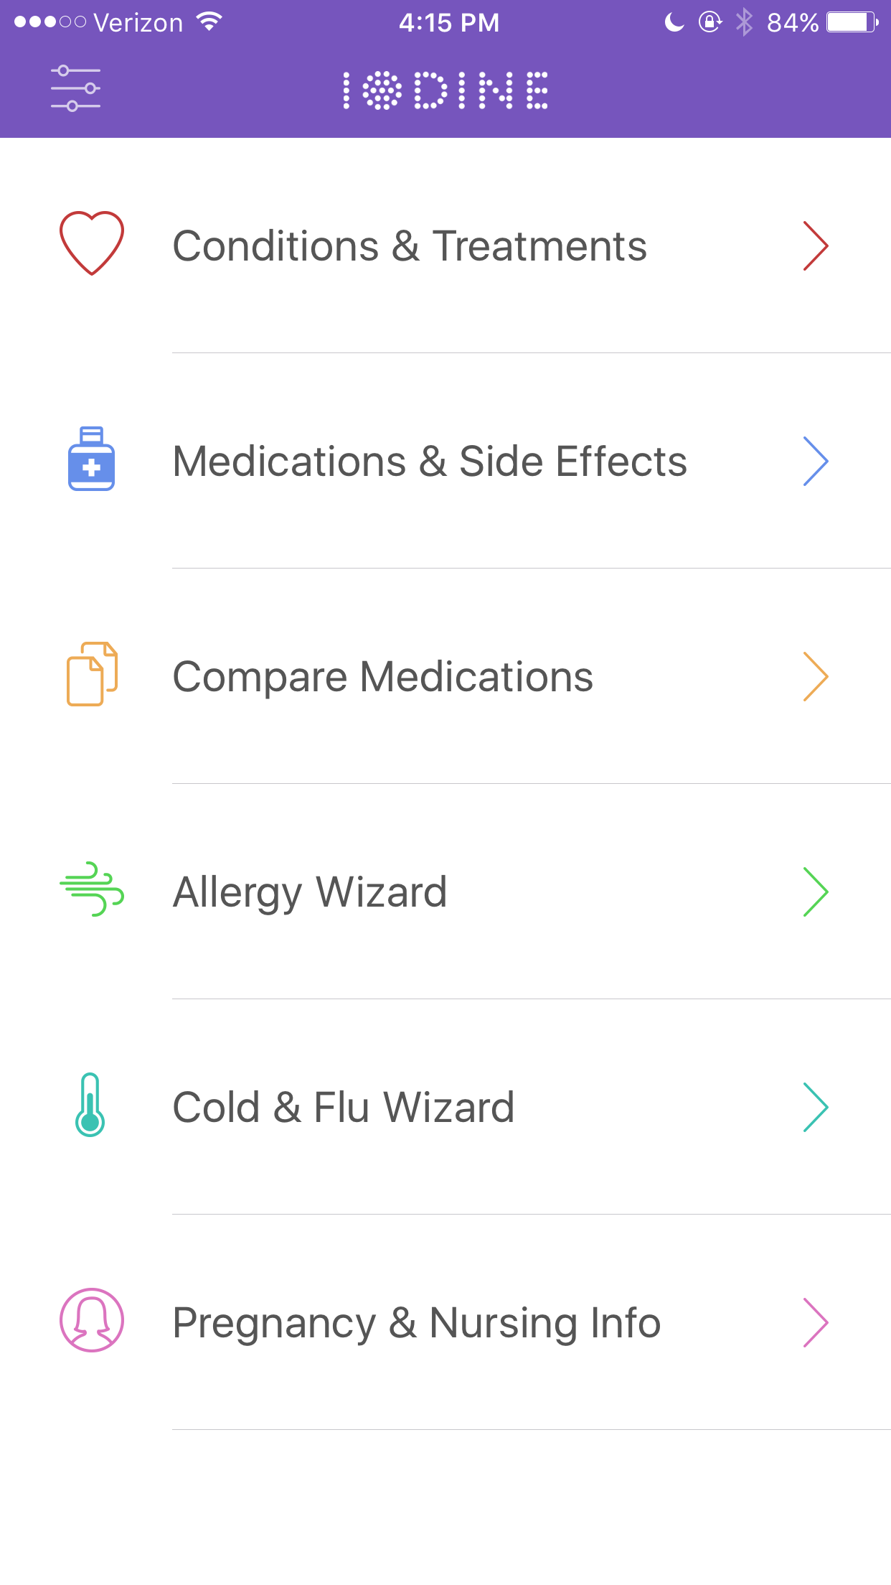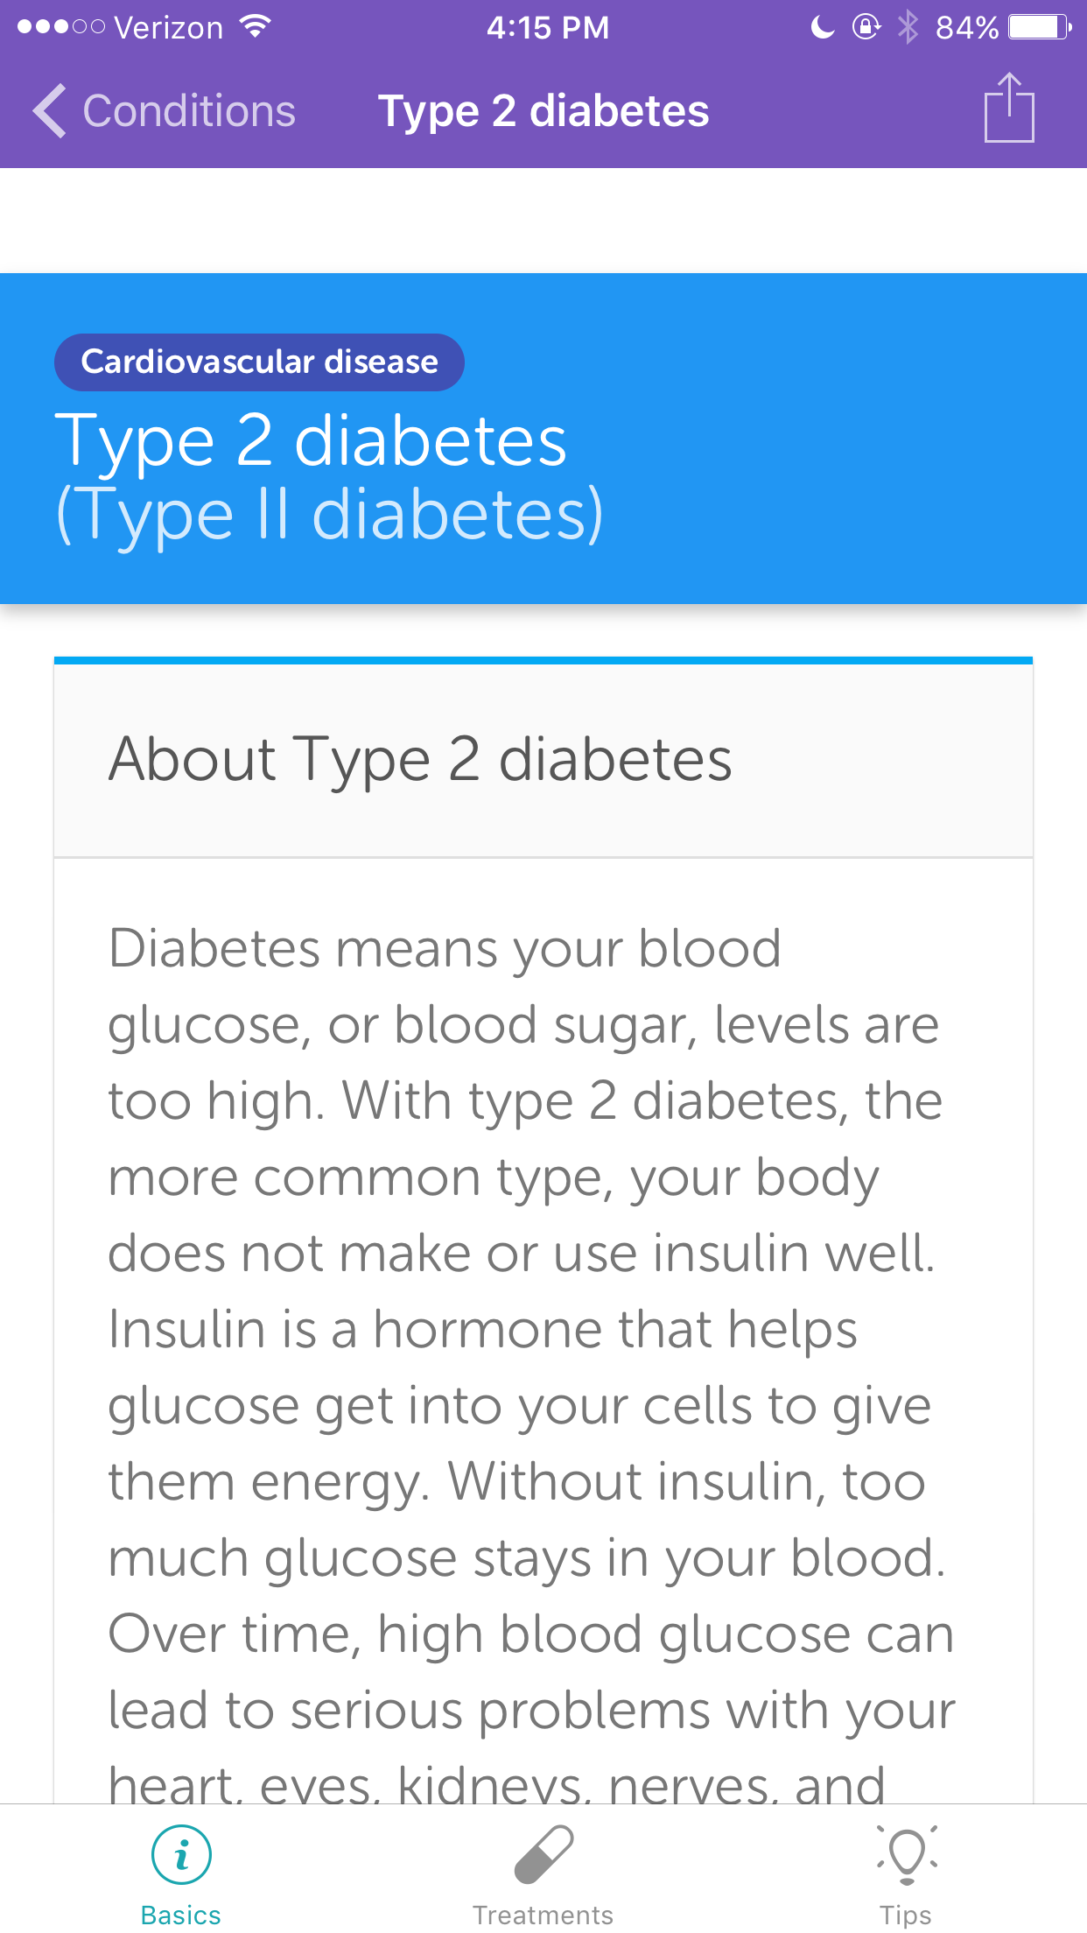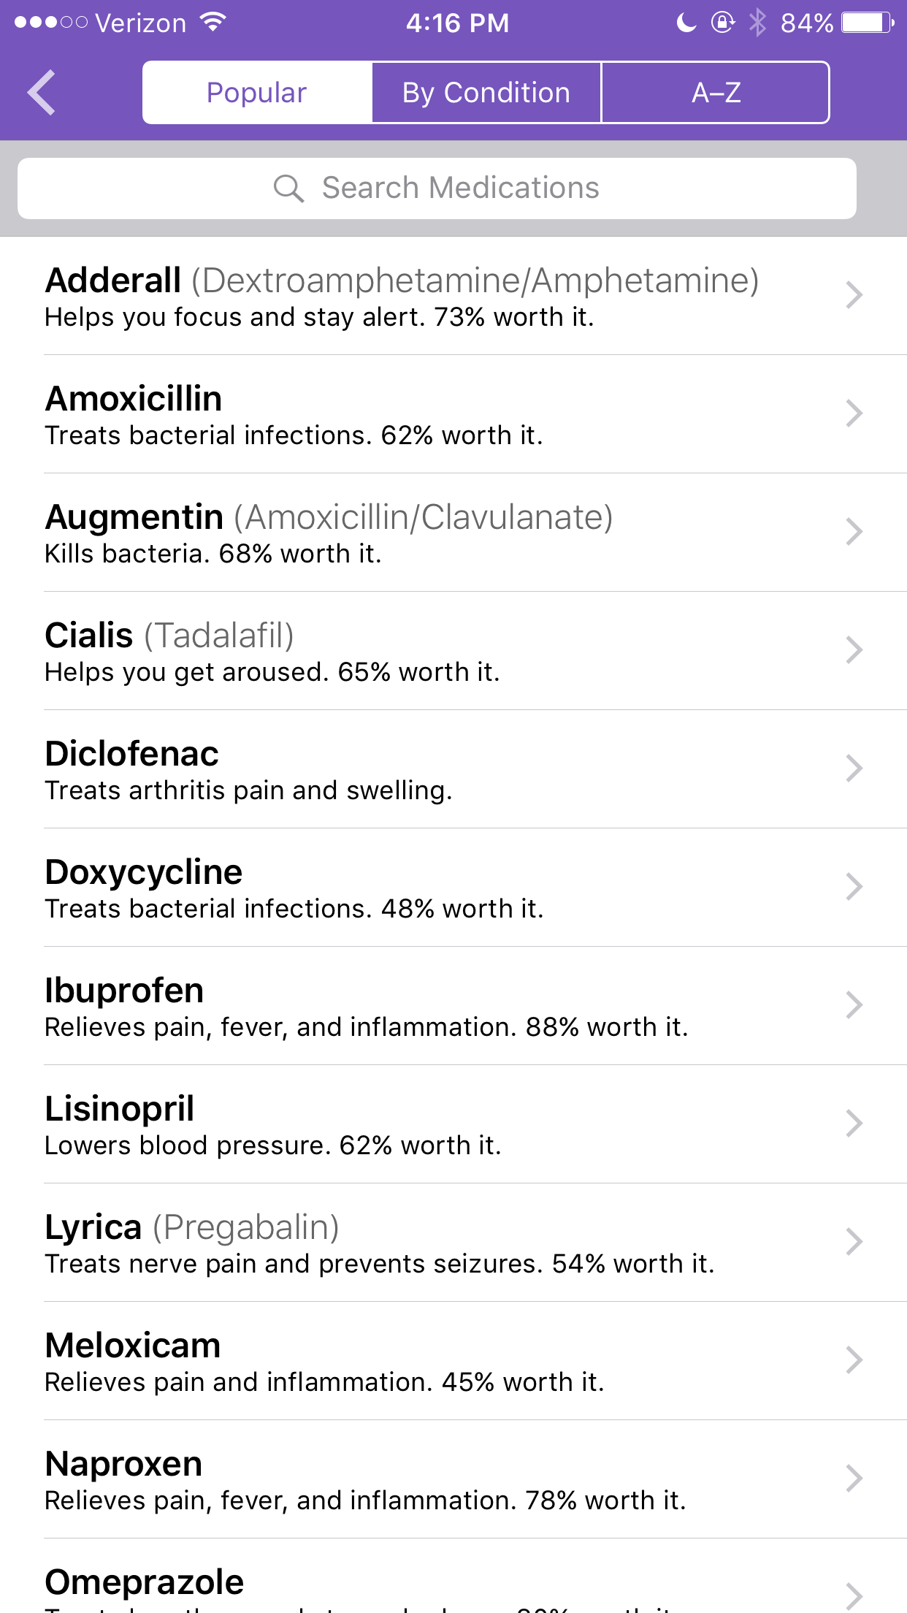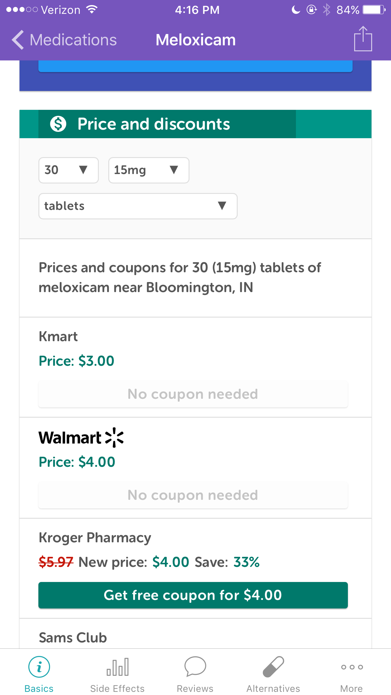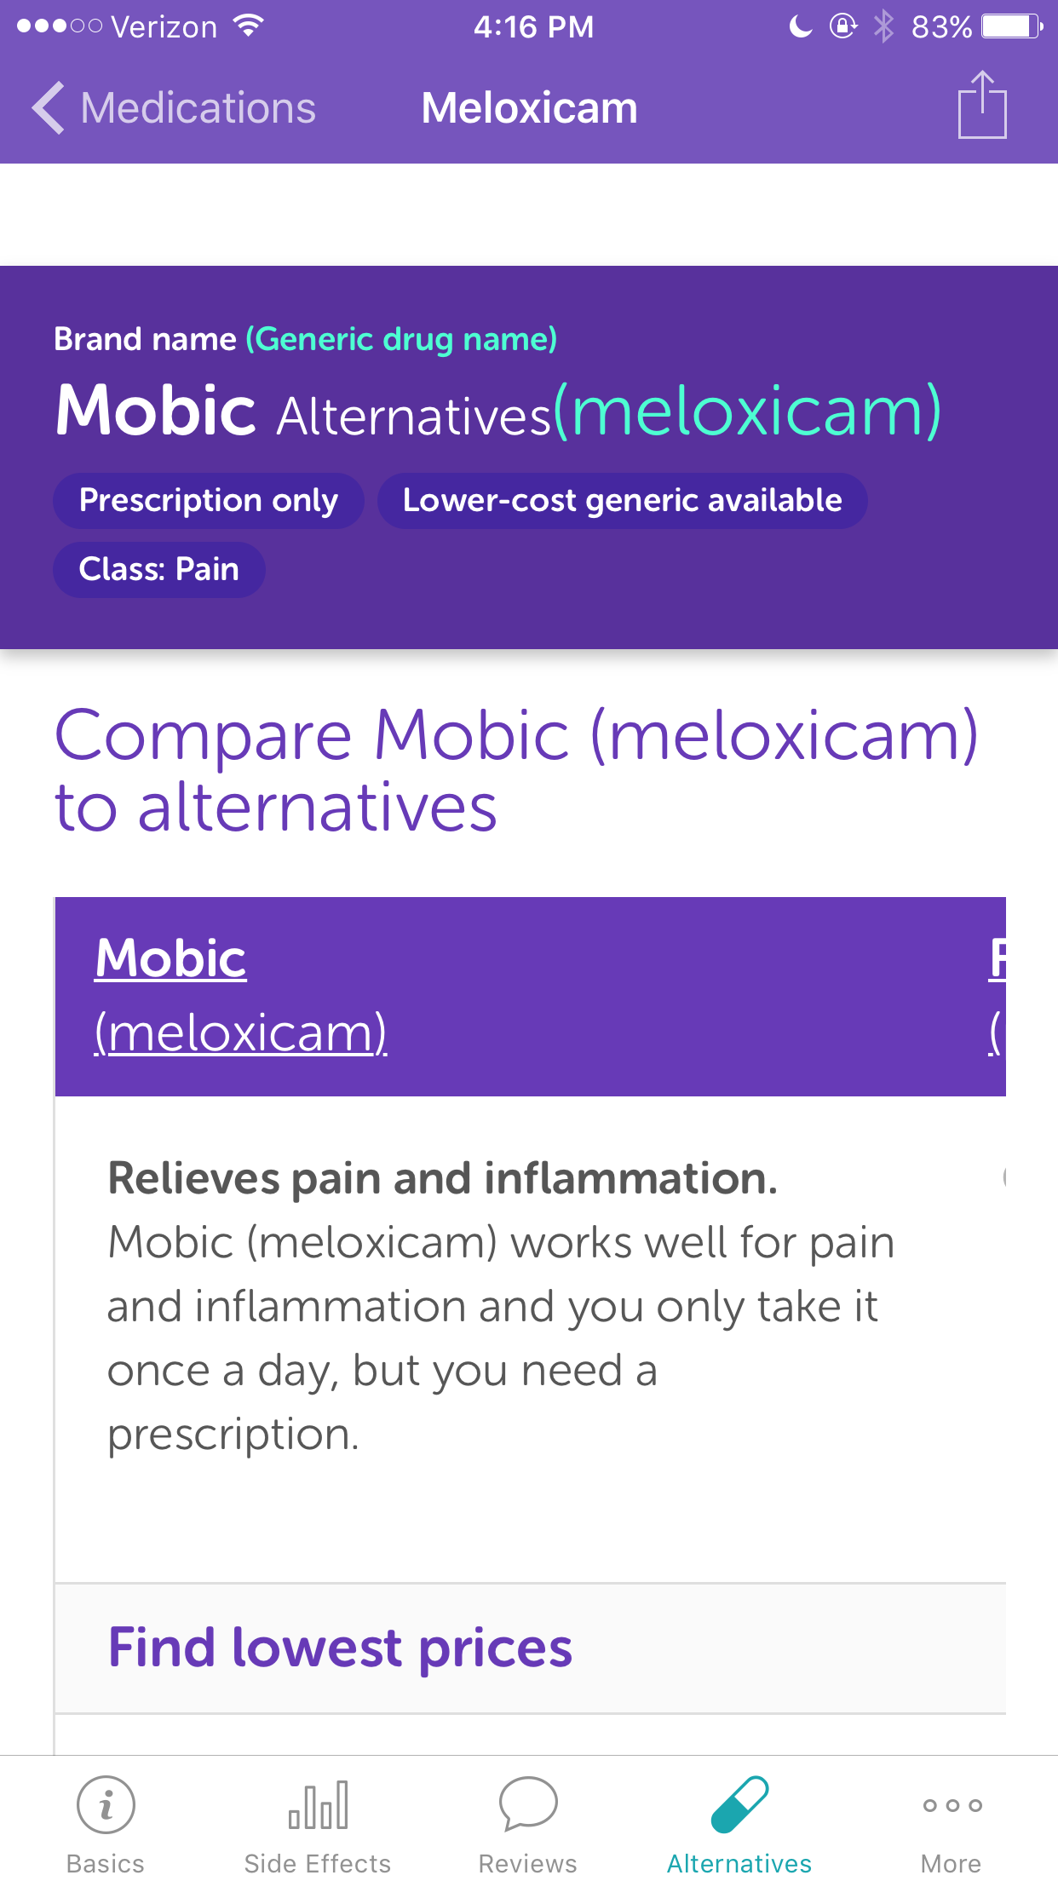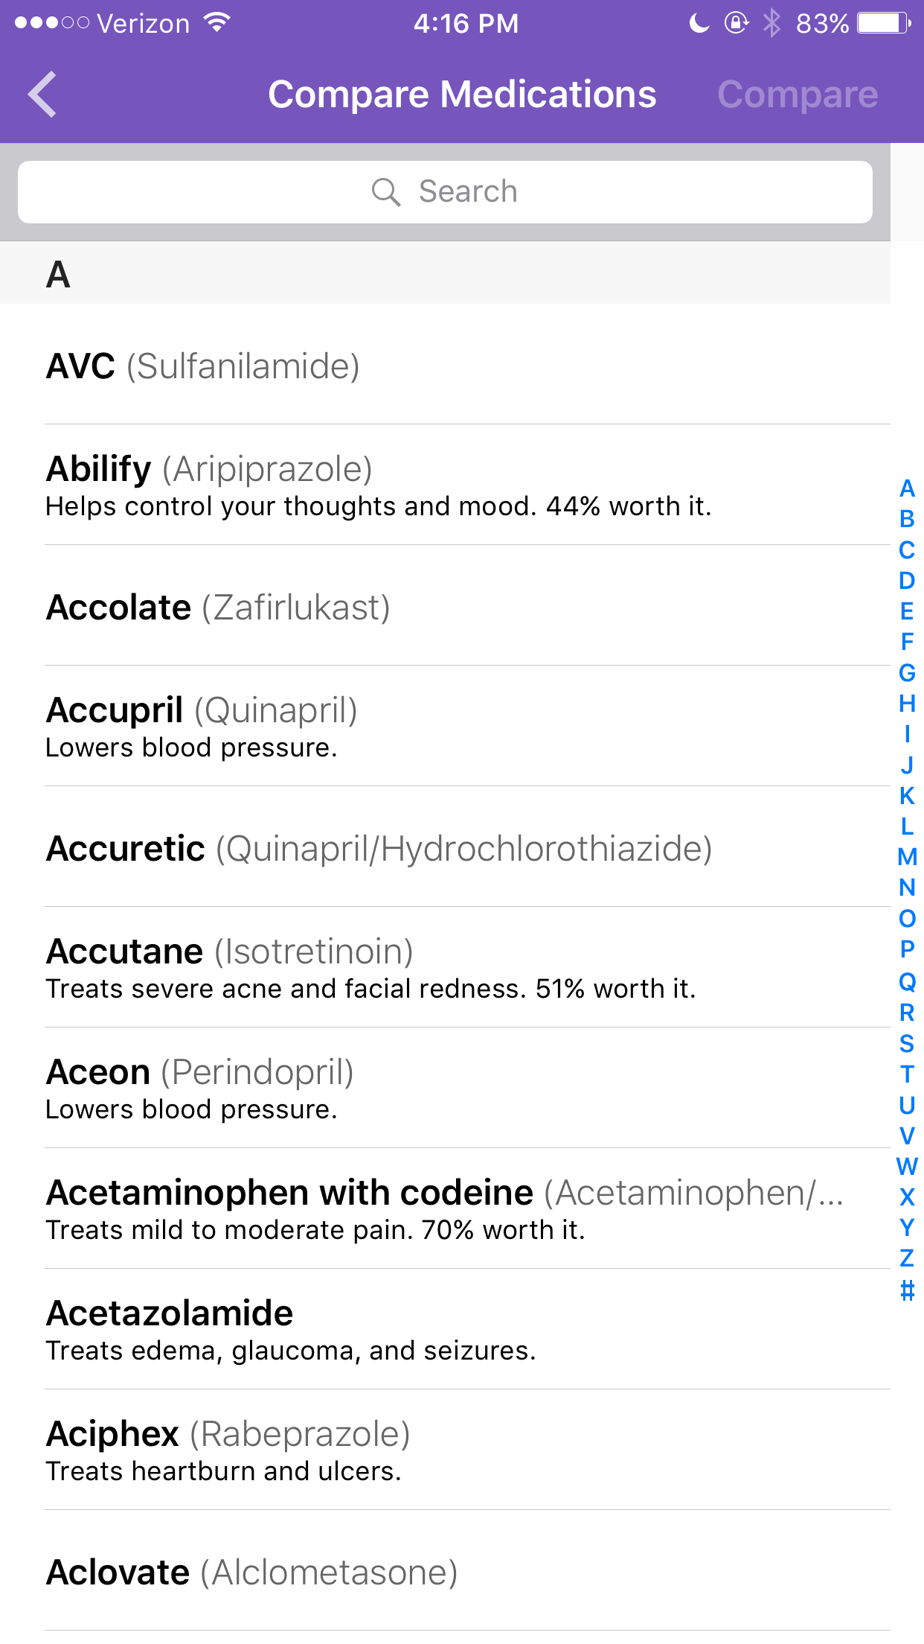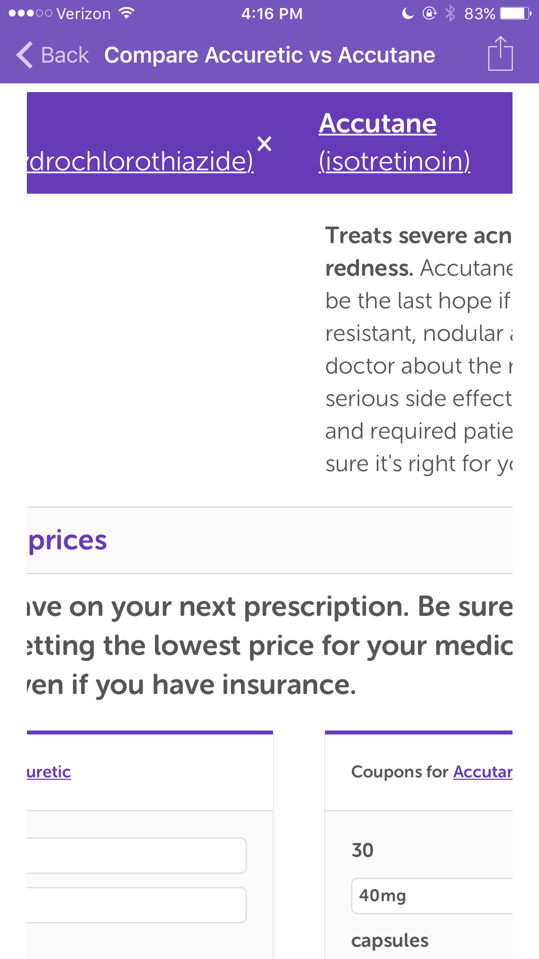

* Allows patients to read about conditions, search and learn about medications
* Can compare medications
* Compares costs on medications to find the cheapest version / cheapest place to get it from
* Can’t store or save meds or track, but good for understanding information

**MyChart - Gabi**

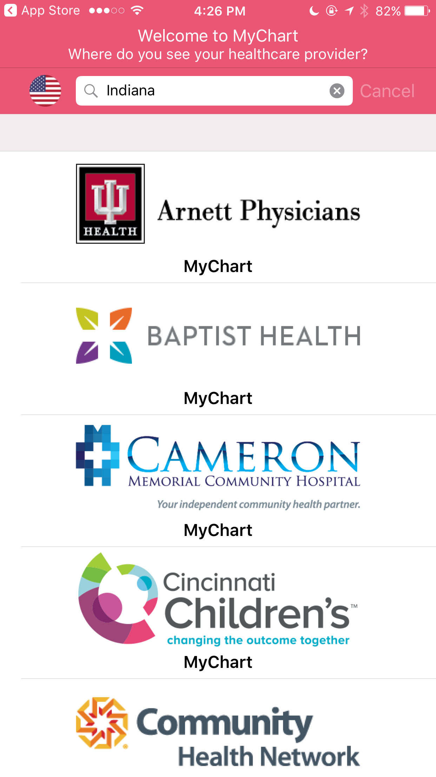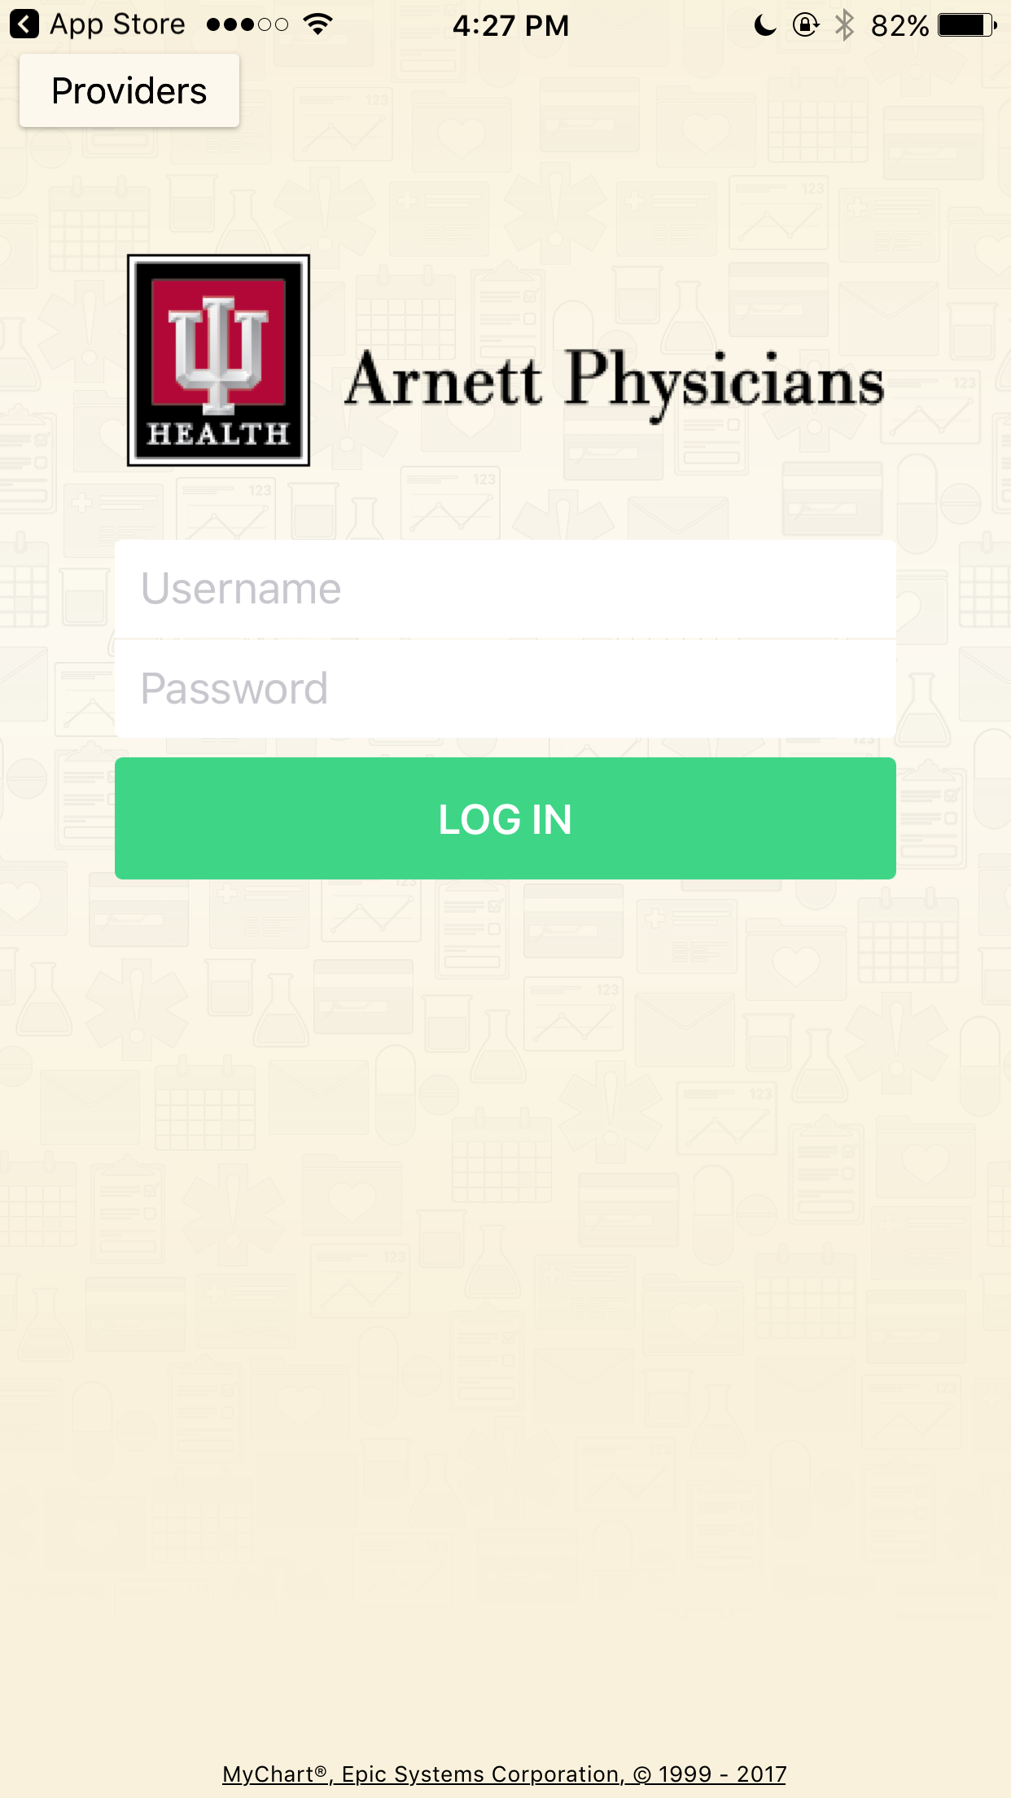

* App asks you to select your healthcare provider, then log in
* I believe (can’t confirm) that it allows you to track health, manage meds, manage appointments, and communicate with doctors within the app
* Encourages communication between patients and providers
* Most reviews like the concept, but say that the app itself is not the best